reachingaprisoner.com
Hello, I prefer using my middle name Shane, I’m 33 years old. I’m hoping to make new friends even overseas in other countries. To be very honest I’m going through it. I’m serving life w/o and fighting to prove the prosecutors coerced people into false testimony to convict me of something I had no part of. This gets really depressing and I don’t pretend to be a saint. I’ve made many wrong choices and had to reflect on my past and I’ve realized who I want to be and what I want to leave behind. I hope I’m able to be blessed with the opportunity to meet someone and show the real me. Not this 128906 Prisoner Webb. I do see myself as honest, very loyal and very outgoing. I’m highly energetic and I search for the positive in everything. There’s always a chance to learn and grow as a person. The glass is always half full and can be toped off. I don’t like to view anything negatively. I’m using this time while locked up to study law. As well as reading other such books to better my knowledge in many aspects. I also have a great addiction to song writing, I love it, it’s my fix when I’m super sad or feeling some love. I also like to draw and tattoo, I’m an artist all the way around. Hopefully there’s someone willing to get to know me, all in all thank you for taking the time to read my profile.

Dereck Shane Webb DOC#128906 CSP (B4-17) P.O. Box 777 Canon City, CO 81215
DOB: 11/18/1986
Gender: Male
Ethnic Background: White
Height: 5ft 7in
Weight: 165lbs.
Hair Color: Brown
Eye Color: Blue
Expected Release: Life w/o
Sexual Orientation: Straight
Looking to Write: ANYONE

Respectfully,
Shane
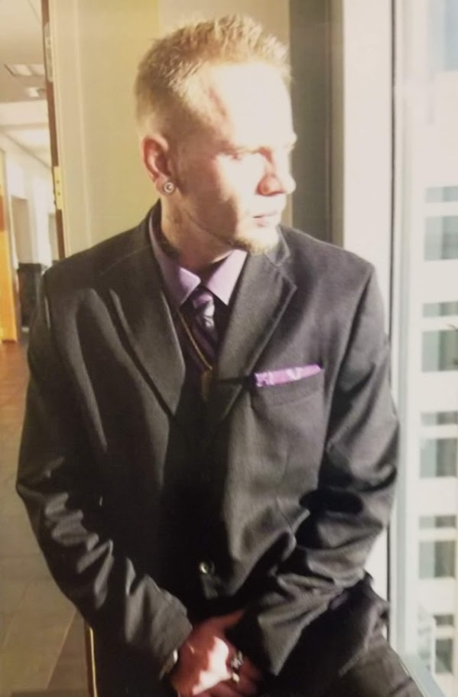
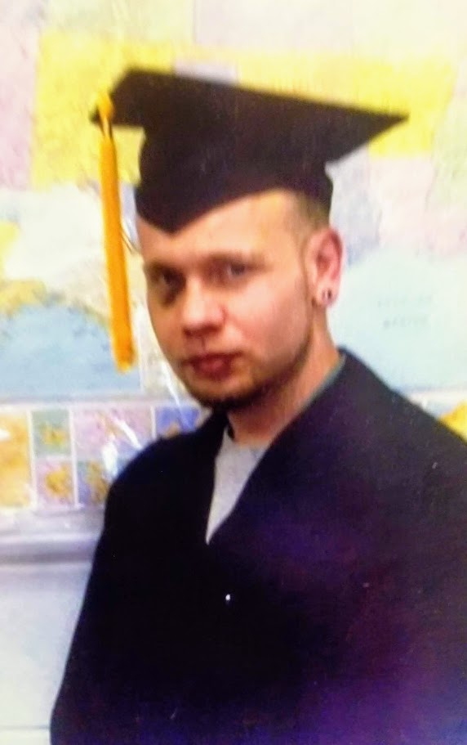
Song Course
Title: Doe’Jee En A Cognac© 2018
By: Shane Webb

Doe’Jee had a cognac-
Dam these flash backs come so fast-
I’m snatched back right onto the past-
But I can’t stay I get too sad-

I see your face within the glass-
The way you taste I wish would last-
I roll this blunt to chase that ass-
But good times never seem to last-
No No No-
Good times never seem to last-
No No No-

I find you in Courvoisier-
I find you in that home-grown haze-
I find in my memories-
The ones I try to drink away-

I find you Courvoisier-
I find you in that home-grown haze-
I reminisce about you baby-
In a cloud I drift away-

Song Course Title: I just been thinking thangs © 2018
By: Shane Webb
I don’t wanna fight with you Babe
-Nah no more-
Every lil thang that we say babe-
I ain’t trying to push blame-
It’s all on me of course-
I just been thinking thangs
I would miss your love-

I would miss you Babe
If you ever walked out that door-
The last look on your face
And your footsteps on the stones-

I would miss you Babe
Should of said this long ago-
All these years may change some thangs
But not the way I miss your Love!-

I would miss you babe
If you ever walked out that door-
The last look on your face
And your footsteps on the stones-
I would miss you babe
Should have said this long ago
All these years may change some thangs
But not the way I miss your love!

Song Verse #2 with hook-Title: What would be light like © 2018
By: Shane Webb
I’m surrounded by this darkness
And I can’t find no stars-
To keep from wishful thinking
Theres no signs of where you are-
Hopelessness keeps creepen up to whisper theres no God-
My face is so damn numb it feels like tears are frozen on-
I don’t know what dreams are made of; will you show-
Show me what it feels like to just to stand within your glow-
Is outta darkness inspiration known to grow-
From whats been tortured can the broken reach for hope
Can the broken reach for hope-
Is there no hope for me-
So lonely this road the longer it gets
The more of a ghost I seem-
High and low been searching for hope so hopelessly-

I ‘ve learned to breath with every break inside my bones-
I’ve learned it’s comforting when pain reminds me of my home-
Then I find myself out searching for some more-
I’ve been accustomed to this darkness baby I just want to know-

What would be light like-
/I just need to know-
What would be light like-
I just want to know-
What would be light like- I just need to know-
What would be light like-

Course/Verse 1
Title: Sexy is you © 2018
By Shane Webb

Yah I know your feeling restless-
Staring at me like your starving affection-
Gurl you know my heart is invested
In you-
But sometimes you be second guessing-you-
Always asking me if your sexy-
Gurl you should know that your sexy-
Maybe your last man couldn’t handle it-
But trust me I know what sexy is-

Sexy is you-
Yah sexy is you-
Baby sexy is you-
Yeah sexy is you-

Verse 1:
Pose for me baby, let me take a picture of that-
Ima prove your bad, right here in this photograph-
Any man is lucky for a chance to get at that-
Si, I know I’m lucky for a chance to get at that-
So, I know I’m lucky I’m the one that’s holden that-
And so you know the facts-
Your heart is in my hands never letting go of that-
Overtime I hope that I’m showing that-
Love the way you shine when I kiss you back-
Took the time, set the vibe like you needed that-
When you told me it was mine I agreed to that-
When you showed me it was mine I agreed to that-
I agreed to that-
Song Course-title: my remedy-by shane webb
Every Time I dream of you Gurl
I wake up in the middle of the night-
I know the Voodoo done by you Gurl
I can’t get no peace of mind-
Where you went I don’t know
And honestly knowing you wouldn’t make it hurt less-
I get it that your gone
Yah the message loud and clear
Now missing you is disappearing next-

I find my remedy on back roads
Tires somken asphalt-
I don’t like tobacco this is Colorado-
This is where that home-grown sticky burning so slow-
With a bottle of that crown
Or a bottle of that Cuarvo-

I find my remedy on back roads
Tires smoken asphalt-
I don’t like tabaco, this is Colorado-
This is where that home-grown sticky burning so slow-
With a bottle of that crown
Or a bottle of that Cuarvo-

