reachingaprisoner.com

Richard Hess DOC# K65598 Menard C.C. P.O. Box 1000 Medard, Il 62259
DOB: 6/19/1973
Ethnic Background: White
Gender: Male
Height: 5ft. 8in.
Weight: 210lbs.
Hair Color: Bald
Eye Color: Brown
Release Date: Natural Life
Sexual Orientation: Straight
Willing to Write: ANYONE
Has Access To: Connectnetwork.com
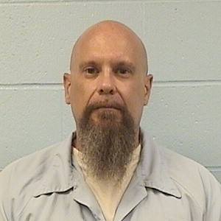

Hey, if you are taking time out of your day to read my profile, THANK YOU! I’m an inmate serving natural life sentence who’s been forgotten by most of society. I figure it’s their loss, not mine, I still have much to offer. Over the last 23 years of incarnation I’ve done rehabilitation work on myself. I’ve done drug and alcohol programs, mental and emotional healing/rebuilding groups and one on one counseling. I’m currently working towards two bachelor’s degrees in theology and Ministry with the hope that I can work towards my Mater’s in Christian counseling. I seen a lot and been through a lot.
Hopefully, I’ll be able to help someone someday who is going through their own troubles or dealing with their own demons. With that being said, I will NOT push my beliefs on anyone. Everyone has the right to their own beliefs and opinions and should not be criticized for them. Besides working on myself to become a better person, I enjoy many other things across the broad spectrum. For instance, I like MMA, rugby, and many other sports, but I also like battlebots and R.P.G. like Dungeons and Dragons. I’m a nerd at heart!!! I love music of all kinds from country to metal and most genres in between. I am a HUGH animal person. Prior to my incarceration, I volunteered at a local animal shelter with the idea that no animal should be stuck in a cage. Regardless, of my photo. I am a good hearted, happy person. Lastly, I took up a new hobby, painting. I’m self-taught so it’s a work in progress.
I’m looking for open-mindness, a good sense of humor, a kind heart and those looking for a long-term friendship. I will respond to ALL who take the time to write me. I will write those overseas who are serious about this……because postage is costly. I’m looking forward to your letter.

Please see page two for my drawings!!!!!!!

