reachingaprisoner.com
Hello, world my name is Ricky, I recently went and seen my doctor and she stated that I was suffering from a bad case of loneness. When I asked her what type of medicine do I need, and she said friends. So, I’m putting this ad up and hopes of finding a real and true friend you can never have to many of those. I know you only get one chance to make a first impression and considering mines involves incarceration let me thank you in advance for not letting where I am define me as the man I have become “today”.

Ricky Andre Thomas DOC#12260434 Snake River Correctional Institution 777 Stanton Blvd. Ontario, OR 97914
DOB: 8/27/1988
Gender: African American/ Puerto Rican
Height: 6ft. 1in.
Weight: 205lbs.
Hair Color: Black
Eye Color: Brown
Expected Release: 8/17/2020
Sexual Orientation: Straight
Looking to Write: Straight or Bisexual Woman
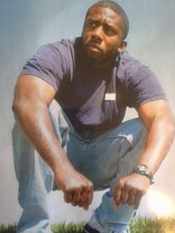

I’m very business minded and love to bounce ideas back and forth with other like-minded people. I love to read different types of books, ones that pique my interest, I love to write and listen to music. I like everything from R&B/Hip Hop to Country. I love to travel. I did a lot of traveling and hope to do a lot more once I’m released. I could use some company.
Since I’ve been in prison, I have gone to school and have a business degree and I’m starting a clothing line I’m gonna have come out a few months before my release. I’m a whole new man and I’ve changed my life around and can’t wait to come on and start this new journey.
I’m all about looking forward and leaving my past in the dust, so if your looking for a new and improved me. Don’t hesitate to reach out to me and let’s build a real bond and see what we can come up with. I appreciate anyone who reaches out to take a chance at us building a beautiful, healthy and successful friendship. I’m laid back and very easy to get along with. So, take a leap of faith is taking the first step even when you don’t see the whole staircase. Talk to you soon.
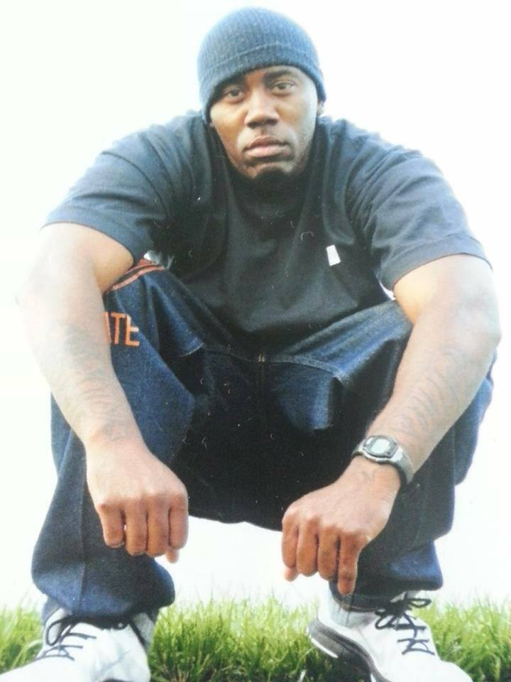

Love is Pain
Poem by: Ricky Andre Thomas

They say love is pain, I didn’t wanna fall in it
But when I met you, you had all of it
Karisma, Klass, beauty and grace
my knees got weak, first look at your face
I wasn’t the type that could be in a relationship
I was the type that just wanna hit it and dip
a wild bio chasin every girl that I see
selfish the only thing that matter was me
then i met you and you played the part
told me you would never play with my heart
I believed you the first time i looked in ya eyes
ya got me wild open baby I can’t lie
I benn running from this love thing most of my life
you make me really wanna make you my wife
got me a taste of ya baby and your sweet as a dove
for the first time in my life i see i need love.

