reachingaprisoner.com
Hi, I’m Dwayne. I everyday ppl in a unfortunate circumstance. Even so I’m all about my progress despite this predicament it’s personal which is why I’m extremely determined in meeting all of my goals entailing above all my freedom while obtaining vocations in law as a paralegal, business management, computer/tech and renewing my CDL among other things.

Dwayne Moore DOC#W101829 S.B.C.C. K-2-Unit P.O. Box 8000 Shirley, MA 01464
DOB: 6/25/1979
Gender: Male
Ethnic Background: Black
Weight: 185lbs
Hair Color: Black
Eye Color: Brown
Sexual Orientation: Heterosexual
Looking to Write: Straight Woman
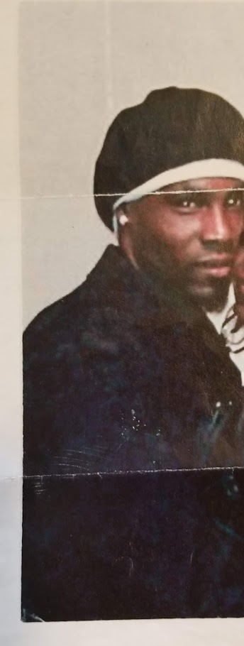

I’m a live your best life no matter the plight, kinda brother, but I know it’s easier said than done. I like hanging out and having a couple of drinks (nothing serious) and socializing but mixing things up on a interactive level 2 with my lady friends.
I have a broad range of interests spaning politics, history and reading. What I thk r a variety of stimulating subjects serving 2 enlighten my mind and expand on my life experiences. I don’t define myself by my appearance or what I posses but by the substance of who I am. Family is #1 in my life that’s my foundation and I love children.
Of course I’m n2 all kinds of sports and music F/B, MMA , boxing, cross fit. Rap, Rock, merenque, calypso, reggaeton, and edm, but I d’nt confuse this w/ me knowing how to step on the dance floor b/c on the dance fl. I might as well be on outer space.
But, I’m the man when it comes 2 board games, xbox, and gaming so what kinda smoke you want Ms. Lady.
Yes as it is, I’ve been really going thru it w/o respite and would like 2 meet a special woman/ just some good ppl who I can get 2 know learn from and possibly build a meaningful bond w/ as I navigate these challenging times and beyond, so if this appeals 2 you let me know somin I love all woman.
