reachingaprisoner.com
Frist and foremost, I want to give a special shout out to all my independent women, single mothers, and intelligent females, in all race, shape, sizes around the globe. My name is Jesus Matos, I’ve been incarcerated since 2014, my appeal is pending. I was born in the US, but I’m from Dominican Republic. I was raised in Corona, Queens. I’m super down to earth, I have a great sense of humor, I love working out, I love dancing and cooking. I listen to Hip-Hop, R&B, Salsa, Batcha, Pop, Tipco, Merneque. (Everything LOL) I’m currently waiting on GED results, after I’m focusing on getting my college degree and a couple trades. I’m just looking for positive friendships, great vibes, good sense of humor, and down to earth. Thank you for taking time out of your day to view my profile, have a blessed day.

Jesus Matos DOC#18A0798 South Port Correctional Facility South Port CF P.O. Box 2000 Pine City, NY 14871
DOB: 7/26/1997
Gender: Male
Ethnic Background: Dominican Rep.
Height: 5ft 10in.
Weight: 194lbs.
Hair Color: Dark Brown
Eye Color: Brown
Does Speak and Write Spanish
Expected Release: 4/4/2030 Appeal Pending
Looking to Write: Woman
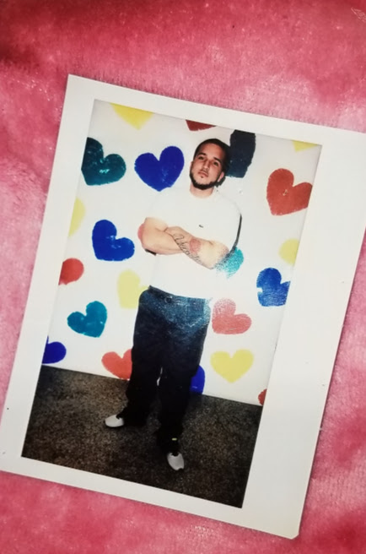

Sincerely,
Jesus Matos

