reachingaprisoner.com
Hello World!

Crystal Marie Leyba DOC# WF9058 C.C.W.F. 511-30-3U P.O. Box 1508 Chowchilla, CA 93610
DOB: 8/23/1988
Gender: Female
Ethnic Background: Native/Hispanic
Height: 5ft 4in
Weight: 200lbs.
Hair Color: Brown
Eye Color: Brown
Expected Release: 10/2026
Sexual Orientation: Heterosexual
Willing to Write: ANYONE
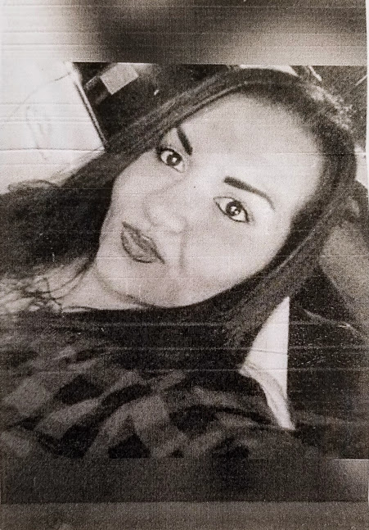

My name is Crystal Marie. I am a 30-year-old, 5ft. 4in., plus sized Native American and Hispanic woman, with baby blue eyes, creamy brown skin, and long satin brown hair.
As you can see, I am currently here at the Central California Women’s Facility, although I’ve made some questionable life choices that got me here, I am using this time here in a positive way to change my life around for the better.
I was born and raised in Fresno, California. Although I lived in the rough part of the city, I was still able to remain soft and optimistic. I come from a very large family, so I ma very family orientated person. I’m a nurturer by nature and would love to use that skill to work with special needs children. I enjoy reading, but my favorite hobby is listening to music. I like many genres in both music and literature. I am currently training to become a Dental Technician. The job is both exciting and very rewarding. I have a really good eye and skill for this trade.
I love to laugh, and I have a good head on my shoulders. I would like to meet a new friend who I can talk with, laugh with, and share interests with. I would like to meet someone with an energetic spirit, someone with good motivation and positive outlook on life. I’m looking for someone who is understanding, open-minded, encouraging, and outgoing, who has a great sense of humor and is also down to earth. I would enjoy a friend who could help me stay connected to the outside world, to keep up with the current events and trends.
I’m very open-minded to who I meet, because I’m not one to judge a book by it’s cover. I hope I’ve peaked your interest and I’m looking forward to hearing from you soon!

Today was the absolute worse day ever
And don’t try to convince me that
There’s something good in everyday
Because when you take a closer look,
This world is a pretty evil place.
Even if
Some goodness does shine thru once in a while
Satisfaction and happiness and don’t last.
And it’s not true that
It’s all in the mind and heart.
Because
True happiness can be obtained
Only if one’s surroundings are good.
It’s true that good exists
I’m sure you can agree that
The reality
Creates
My attitude
It’s all beyond my control.
And you’ll never in a million years hear me say that
Today was a good day.

(*now read from the bottom to top)

