reachingaprisoner.com
To judge a book by its cover, is the easiest way to deny yourself an opportunity to grow; a picture may say a thousand words but never tell the whole story. Hi, my name is Dante Taplin, and I encourage you to allow yourself the privilege of meeting one of the most sincerest, motivated, loving, dedicated, trustworthy, engaging people you will ever meet.

Dante Taplin DOC# 12800067 Two Rivers Correctional Inst. 82911 Beach Access Road Umatilla, OR 97882
DOB: 8/27/1980
Gender: Male
Height: 6ft. 2in.
Weight: 220lbs.
Hair Color: Black
Eye Color: Brown
Expected Release: 1/2024
Sexual Orientation: Straight
Looking to Write: Straight Woman
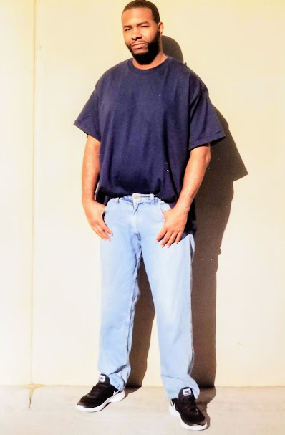

Though some people use these pen pal sites to find love, I am looking to find friendship, partners, and help shed light on a highly sensitive, and polarizing subject affecting approximately 2.2 million Americans in this country, not to mention those we left behind that love us. I am speaking primarily about the criminal injustice system, specify the misapplication by police and prosecutors in my home city/state of Portland, Oregon.
Yes, I am single, but not alone in my current situation. Yes, I have a record, yet I do not allow it to define me. I am a published poet, a voracious writer and soon to be one of the premier voices in the fight for criminal justice overhaul, and the renaissance of not only African Americans, but of those of us that find ourselves trapped, under served in the criminal justice system.
I stand 6”2’, 125 pounds, my interests electric. I love writing poetry, the outdoors, camping, hiking, reading, writing, and helping people. I am interested in likeminded people who wish to share their journey of redemption. I am a parent, I have a 15-year-old son. I am 35 years old, Virgo, and someone who takes pride in learning new things, meeting new people, experiencing new cultures, and standing up for those without a voice. I look forward to hearing from you soon. Please, I’m not interested in homosexually.
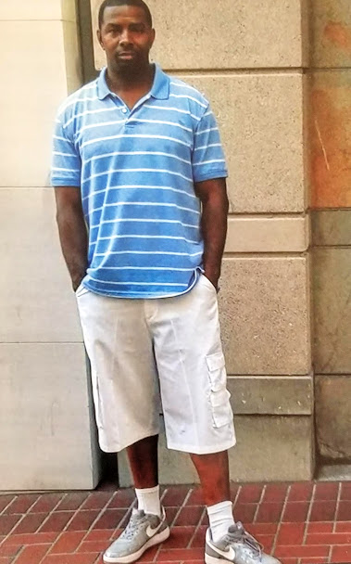

Light

I am love, I am light, I am everything
wrong with being right.

I am what shouldn’t, what couldn’t, but di,
Am I wrong for being RIGHT?

NO, I am whats wrong with being bright,
i am the heat in the sun.
What’s wrog with being the light?
I am the heart of the warrior, who’s
sent in to fight.

I am seeing in COLOR; your vision is slight.
Are you seeing my sister, my mother,
my brother, my life? What you see in my color
we see in each other, the love and the light.

Cohesive they hate, but love when we fight,
The hate that you gave, has filled every
grave, no color, no light.

Get it? love equals light, so nothing
I am, and nothing we are, is different
cause love is what made us
Right?
by: Dante Taplin
2018

