What I am looking for in a pen pal is a person who understands that presence is more than just being there. A person I can share a few laughs with. The purpose of this ad is to establish a friendship based on understanding, thoughtfulness, and honesty. I’m currently working as a trainer for rescue animals, trying to give these dogs a second chance, which is exactly what I’m looking for since I’m currently incarcerated, but soon to be released. I don’t know if I’ve found that someone through this ad or not, so let’s share the chance to find out. Fell free to get through www.jpay.com Id number 813800 or by mail at the address provided.
Jessie Osalde DOC# 813800
Clallam Bay Correctional Center
1830 Eagle Crest Way
Clallam Bay, WA 98326

DOB: 12/25/1979
Gender: Male
Ethnic Background: Hispanic
Height; 6ft. 1in.
Weight: 210lbs.
Hair Color: Black
Eye Color: Brown
Expected Release: 6/9/2021
Sexual Orientation: Straight
Looking to Write: ANYONE
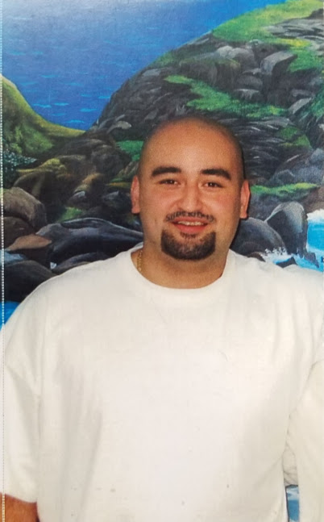
REACHINGAPRISONER.COM

