reachingaprisoner.com

Todd J Miller DOC#78082 Warm Springs Correction Center P.O. Box 7007 Carson City, NV 89702
DOB: 12/7/1969
Gender: Male
Ethnic Background: Caucasian/White
Height: 5ft 10in
Weight: 170lbs.
Hair Color: Brown
Eye Color: Brown
Speaks a little Spanish
Expected Release: 5/9/2021
Sexual Orientation: Straight
Looking to Write: Straight or Bisexual Women
Has Access to Corlinks
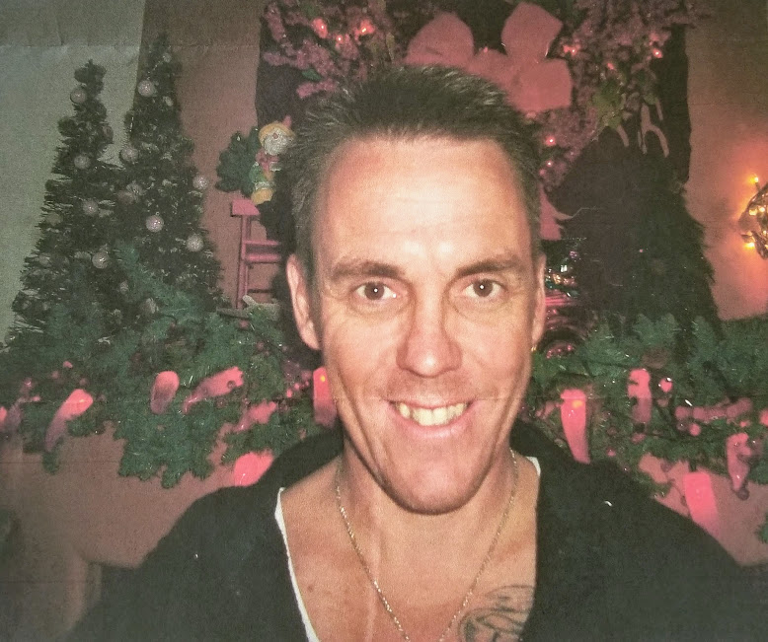

I’m a fun-loving guy who likes to laugh and enjoy himself (I like a good sense of humor)I’m very much a thrill-seeker who looks for excitement and adventure. I’m into fast cars and motorcycles, all types of sports, and rock and roll. I keep my mind and body healthy and strong by exercising them both everyday. My hobbies include: scuba diving, going to yard sales, watching Jeopardy, and playing in poker tournaments. I will go out of my way to help the needy whenever I can. I am a HUGH animal lover and get a great joy out of volunteering at animal shelters. When I get out I want to follow my dreams of being a service and therapy dog trainer. I try to live my life as best I can by following the “Nine Noble Virtues”. I am NOT a racist or a gang member an I have NEVER committed a violent crime or sexual crime in my life. I am 100% honest about myself and expect the same in return (no “catfishing” please). You can always look me up on the Prison website (www.doc.nv.gov) or on Facebook (Las Vegas, NV). I would love to hear from any and all of you, so drop me a letter and let’s get to know each other.
“ Life with all it’s joys, struggles and ambiguities, is to be embraced and lived to the fullest.”
