reachingaprisoner.com
When writing me you’ll encounter someone who’s an everyday, regular individual that’s very much like most everyone else. Something that may set me apart is the fact that I’m open, honest, understanding, and have a genuine interest in who you are as well as what brings you enjoyment in life.

Terence Wayne Andrews DOC#875865 Stiles 3-C-53T 3060 FM3514 Beaumont, TX 77705-7635
DOB: 10/29/1977
Gender: Male
Ethnic Background: Caucasian
Height: 5ft 8in
Weight: 145lbs
Hair Color: Brown
Eye Color: Green/Hazel
Expected Release: 4/28/22 through 4/28/2037
Sexual Orientation: Straight
Looking to Write: Straight Woman
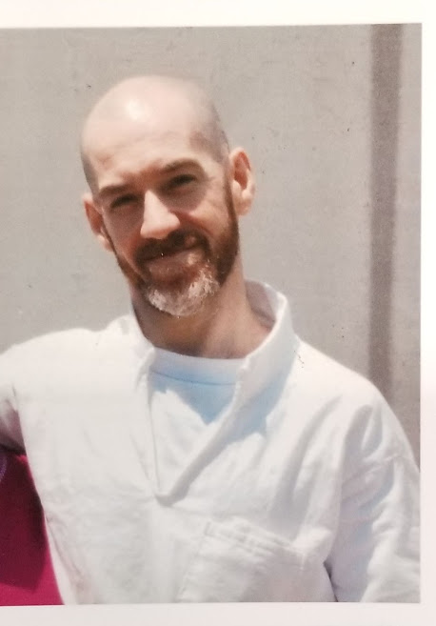

I’m sincere, genuine Christian who doesn’t seek to force my faith upon others, nor do I believe we should live in each chamber that restrict open and genuine conversation of differing view. Some of the activities I enjoy are reading novels and non-fiction, listening to rock/alternative music, watching movies, working out, playing handball, playing boardgames with friends, sharing a good laugh, cooking, and attending classes to better myself as well as prepare for life outside of prison.
I’m an outdoors person that was very active, preferring not being cooped up inside. I love the rain and beauty of nature. I’m also a hopeless romantic, a real sucker for a love story in books, movies, or music.
In the spirit of being open and honest, I’ve been living with HIV for fifteen years and enjoy good health as a result of taking care of myself while adhering to my prescribed regimen. I value openness and honesty, which is why I elect to be upfront with this information no matter how awkward or embarrassing it may be for me. This also fair for you in case it affects your decision to write.
Meeting “THAT SPECIAL SOMEONE” is something I’m very open to, though I’m also quite excited about the new people I’ll be meeting and resulting friendships that are possible. I look forward to meeting new people that share similar interests and likes as well as learning and trying new things.
Coming up for parole in April 2022 has me eager to embrace life once again, especially interacting with interesting people outside of the prison life experience.
So, if you’d like to meet someone that isn’t about games, lies, and a big ego, drop me a line for a breath of fresh air and new experience.
