reachingaprisoner.com
Hello, I’m an open-minded, genuine, down to earth guy who enjoys sports, outdoors, music, reading, scary movies and I can’t lie chick flics, and I love to cook. Although, I haven’t got do much cooking as of lately.

Donnie Shaw DOC#14588756 Snake River Correctional Institute 777 Stanton Blvd. Ontario, OR 97914
DOB: 9/19/1983
Gender: Male
Ethnic Background: Caucasian
Height: 5ft 8in
Weight: 175lbs.
Hair Color: Blond
Eye Color: Hazel
Expected Release: 4/9/2032
Sexual Orientation: Straight
Looking to Write: ANYONE
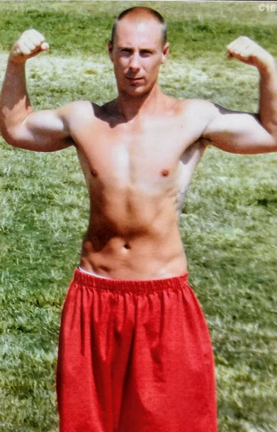

Prison is very routine place and seeing the same faces of people you might not want to see gets old. So, I’m looking to meet someone new who can make my days a little more interesting. I don’t expect anything more than a hello.
I’ve made some mistakes in my life for which I am truly sorry, I can’t live in the past, all I can do is live in the now and move forward. If your someone who can look past my failures and wants to get to know a good-hearted guy, I look forward to hearing from you.
Thank you for taking some time and visiting my page Be safe and take care.
Donnie
