reachingaprisoner.com
Beloved Friend,

Peter Randle DOC# K66611 Shawnee Correctional Center 6665 State Rt. 146 E. Vienna, IL 62995
DOB: 9/8/1978
Gender: Male
Ethnic Background: Black
Height: 5ft 11in
Weight: 232lbs.
Hair Color: Bald
Eye Color: Brown
Expected Release: 09/08/2042
Sexual Orientation: Straight
Willing to Write: ANYONE
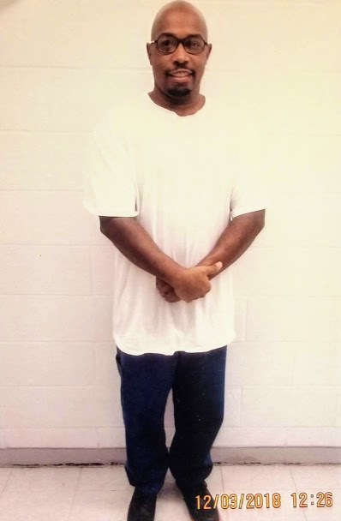

Wow! You finally found me. I’ve patiently waited to hear from you, and now you’re here. I want you to know that during this waiting period I’ve grown tremendously, and my time wasn’t wasted idly engaging in foolishness. I’ve been fighting the good fight striving to become a better man, growing in knowledge, wisdom and understanding, studying the works of Ernest Holmes, James Allen and Charles F. Haanel (Just to name a few). The study of culture and history has also helped in my development, reading to works of U.A. Rodgers, John H. Clark, Madame Blavatsky and Dr. Wesley Muhammad. As you can see, I keep myself busy. I’ve become a college student pursuing an associate degree in liberal arts. But now I’m ready to delve into the realm of hope and possibility, with you.
My mind is in constant contemplation wondering- How is your day going? What’s on your mind? What challenges, beauties and obstacles has life presented you? I eagerly await the honor of meditating on your words, hoping in return I can offer encouragement, wisdom and smile.
I hope that we can build a bond where you are willing to share your hopes and dreams. Passions and cares, all of this and more I offer to you as a loyal friend. My mind =, heart, and arms are open, are you ready?
Just knowing that you are reading this ad shows me that you have an open heart, please allow me to motivate you to take the next step and connect with me. I will not fail you nor will I disappoint you. My only motive is to build a genuine and sincere friendship, I am an open book, my word is bond and honestly will always be the guiding principle in friendship.
I’m ready, I’m waiting. Stay blesses and know that I’m thankful for the time you invested in reading these true words. O can’t wait to here from you. PEACE!!!!!
YOUR FRIEND,
PETER

Broken Smiles

Broken smiles still love to laugh,
Broken smiles try harder to last.

Broken smiles cherish the Joy,
Broken smiles are rarely coy.

Broken smiles are trust in deed, because
Broken smiles are the truest in need.

Broken smiles don’t run from the day,
Broken smiles light the way.

Broken smiles are ways to cope,
Broken smiles never give hope.

PEACE!!!!

My Soul Is Moving
I smile through the pain of a heart
That’s broken, I love in spite of words not spoke.

I care for reasons that eyes can’t see,
I want for things that can’t possibly be.

My thoughts run wild of horizons to come,
Beautiful night sky’s with reservations for one.

Dreams of a past that no longer exist,
With hope of a future surrounded in bliss.

I await the rays of the glorious sun,
To show the world I’m far from done.

PEACE!!

