reachingaprisoner.com
*Pick Me *Pick Me *Pick Me*

Glenn Greer DOC#158258 Arizona Department of corrections- Lewis- Unit- Rast P.O. Box 3600 Buckeye, AZ 85326
DOB: 10/20/1978
Gender: Male
Ethnic Background: English, Irish, German, French, Dutch
Height: 6ft.
Weight: 195lbs.
Hair Color: Bald
Eye Color: Bald
Expected Release: Life
Sexual Orientation: Straight
Looking to Write: ANYONE

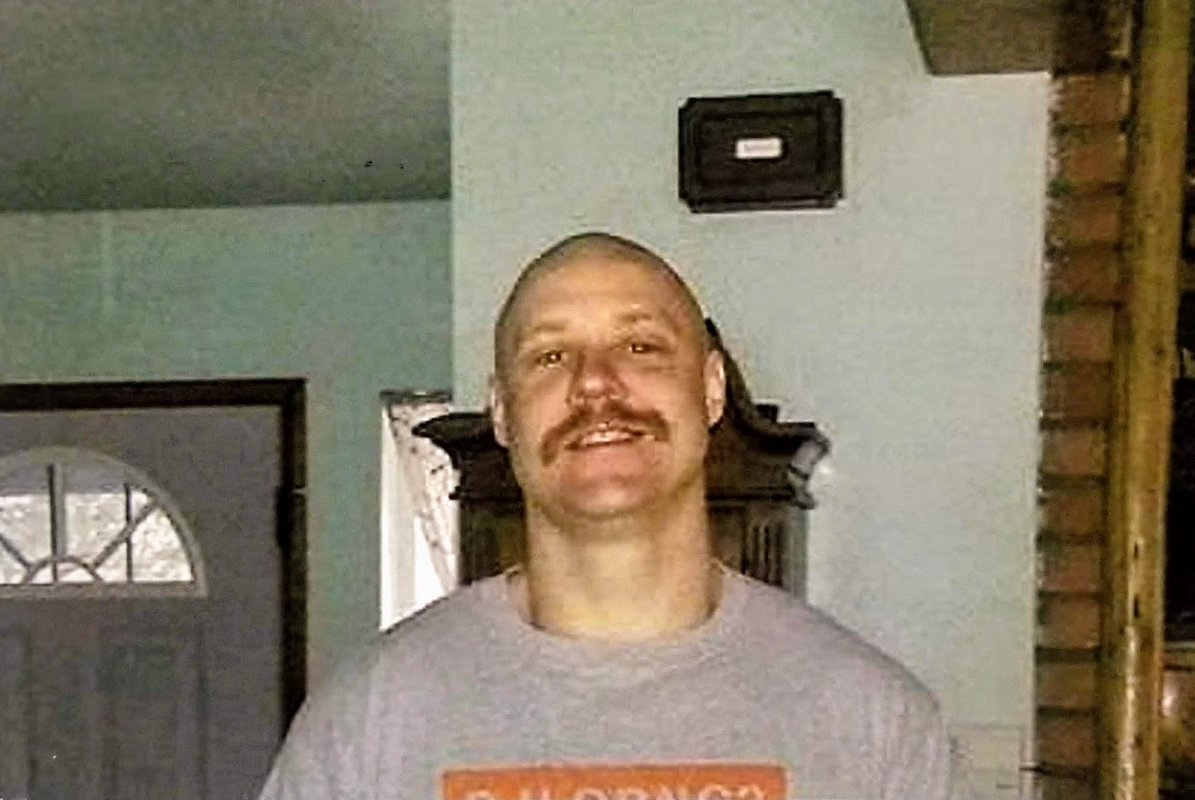

I feel like a stud at auction; “gather round, gather round folks, we’ve got a real beaut looming the block. He’s got a strong back and handsome front w/ a rowdy spirit and query disposition…. But the reality is more of a cross between that adorable Mastiff puppy you see yapping in the pet store window, trying to get someone to rub my belly and take me for a walk, and a hooker strutting naked and bold waiting for my pretty woman dream come true….. HA! HA! Obviously if (when) you choose to write me there will be no shortage of laughter, but I must be candid, there is also a deeper side of me as well. I do not only seek to “pass the time” with trite words, I hope we can find something meaningful, something uniquely ours….. whether our affinity is purely platonic or overtly intimate it is one I look forward to. Do not be afraid to be yourself unabashedly. I seek to know you, not who the world thinks you should be. Whew, picking a rose I don’t seek out the one devoid of imperfection or flaws. I do not reach for the one in the purest sunlight. I look for the one that holds onto its wilted petals, the one that refuses to cast them below. It is the rose cast in the shadow that demands my attention, the one who had to fight for the sunlight, that one, that shows a lust for life. It is the rose w/ a few more thorns that I reach for, because it commands strength and courage to hold onto, it invokes truth, which rose are you? Don’t hurt yourself diving for the pen and paper, I know how bad you want to write, but make sure you have my address correct. I’d hate to miss your words…
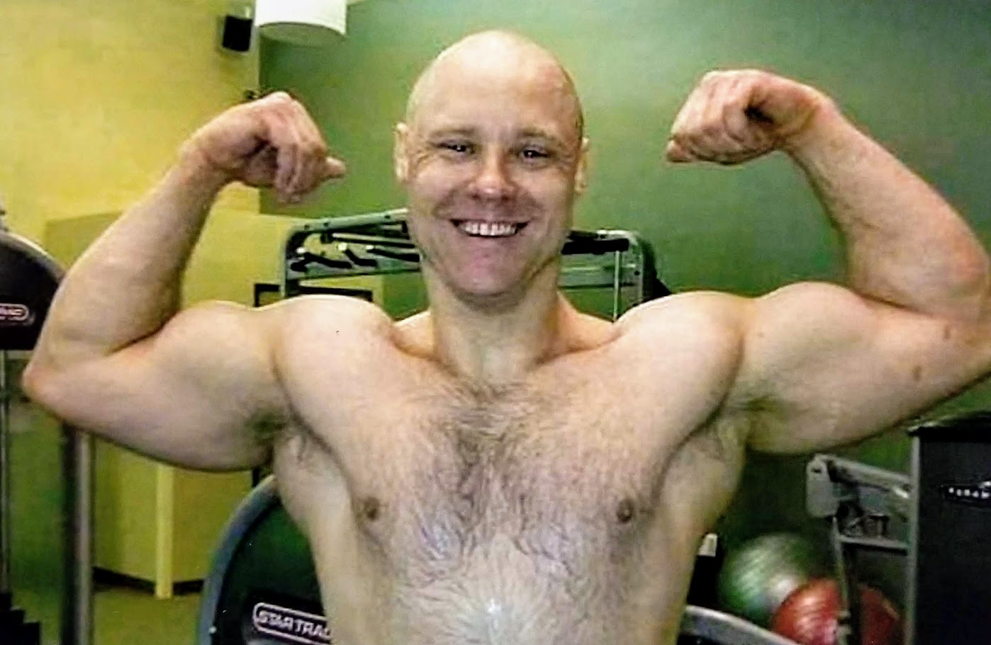

In the beginning life was finite,
Hopeful and boundless was the future,
too crippled with fear
Last opportunity of empty givings
and sincere decaits
platted destruction rot w/ mayhem
endevered misery’s of purgatory
w/o any wisdom or fare thought
old age came to hold my hand
and comfort dreams gone dead….

A throbbing temperate soul weeps to feel something,
Anything, to be, to exist, to matter beyond itself or conquer
Itself in betterment of itself…

The soul must have purpose, ability to transform and develop,
Inspire and mutate. Because destiny is the evolution
Of one’s soul, the completeness of maus journey.

We wander blind and ignorant, hoping something, someone,
Anything or anyone will give our life meaning to give of oneself beyond
Our self is selfless…….. while kind of deed it is not selfless, we did it for our own self worth
And search to complete our souls’ salvations.

We (man or woman) must come to term with ourselves; demons;
Glories; depredations; achievement; sacrifices; pride and failures.
My misery, torment, happiness, or secret hopes are for me to
Cherish and morn as I see fit without judgement, scorn or influences. I determine whether I will give myself and that is selfish, but honest….

