reachingaprisoner.com
Maurice Baldwin Canty DOC# 01311118 Michael Unit 8-L-10B 2664 FM 2054 Tennessee Colony, TX 75886
DOB: 09/29/1964
Male
African-American/Black
Height: 6ft 2in
Weight: 235lb
Hair Color: Bald
Eye Color: Brown
Expected Release Date: 6/20/2034
Sexual Orientation: Straight
Willing to write: Anyone
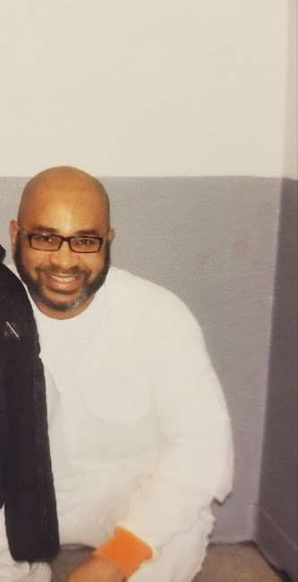

Peace World,
My name is Maurice “Big Moe” Canty. I am from New Orleans, La. I am seeking a faithful Pen-Pal that will be genuine in writing to me. Warm, loyal, caring, positive, strong, brave and understanding. Someone who is open minded that will be as honest with me as I am with them. I am looking to start a beautiful friendship. In this world we are all in need of a friend. Mistakes in life are common, yet unfortunate. Corresponding is such a beautiful art, I have plenty of paint all I need is some water. I am intelligent, energetic, and attentive. I have become a brilliant listener, compassionate and I love people.
And as funny and peculiar as it may sound, I’ve developed a much better sense of humor. I have learned that it is vital for my psychological and emotional wellbeing. How to do feel about that? I like to show love and wisdom by inspiring, enlightened, and motivate. What about your standards? I set standards first, being strong, fearless, determined, unbreakable, devoted and dedicated. I love football, played from the playground to a short stay in college. I love acting also, you can see me in the 2004 movie “Still About It” by Master P. I love Culinary Art. Cooking is beautiful and one of my specialties. I’m also the coordinator of the educational, substance abuse and counseling program. Vindication and ultimately liberation is a must.

Sincerely,
Maurice

