Reachingaprisoner.com
How are you? I would like to tell you a little about myself.

Ronnie Allen #11560581
Eastern Oregon CI
2500 Westgate
Pendleton, OR 97801

DOB: 4/24/1977

Gender: Male

Ethnic Background:

Height: 5ft 11in

Weight: 200lbs.

Hair Color: Black

Eye Color: Brown

Expected Release: Goes before Poral Board 2020

Looking to Write: ANYONE

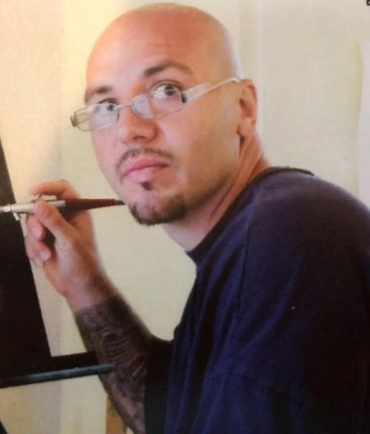

I am a positive person who tries to use positive words, actions, and thoughts that are powerful and productive to break free from my past and move forward. The last 3 years, I have been a lead trainer for a service dog program. We train dogs on 92 different cues to help assist veterans and others with disabilities. The dogs help their humans be independent again. Giving back to society while in prison has been gratifying.
I also teach communication classes to help inmates navigate difficult situations without resorting to violence to solve their problems. I want to help change the prison culture and believe this is another way I can make a positive contribution. In my free time, I'm an artist. I'm a Big Brother and Survivor superfan. I'm a good listener and hope to inspire someone to reach out and make a new friend and pen pal.

