reachingaprisoner.com
Sorry I don’t have any pictures of me smiling. It’s because usually either some “tough guy” taking the pictures or the CO’s rushing us, which can kill the mood, but for the record, I do have all my teeth! I am from Columbus, Ohio but was born in the South. I have an old school mentality and things like morals, principles and values are important to me. Loyalty and honesty are front-runners in my actions. I’m looking forward to corresponding with someone who is down to earth, non-judgmental and has a sense of humor. Laughter sooths the soul. Discrimination is not in my vocabulary. I enjoy working out, reading all types of books from history, politics, religion, sports, mystery, conspiracy theory, to erotica! As well as I listen to hip hop, country and jazz. Knowledge is power and I pride myself on education and growing my mind. I’m constantly building and completing programs and educational courses. I’ll always keep it real and never play games or waste on valuable time. I’m willing to discuss any and everything and will answer any questions you may have-truthfully. My body is locked up, but my mind is free, and my heart is pure.

Robert Brandon Ledbetter DOC #69484061 United States Penitentiary Max P.O. Box 8500 Florence, CO 81226-8500
DOB: 4/11/1979
Gender: Male
Ethnic Background: Bi-Racial
Height: 6ft 1in
Weight: 180lbs
Hair Color: Bald
Eye Color: Brown
Expected Release: Life
Sexual Orientation: Straight
Looking to Write: ANYONE
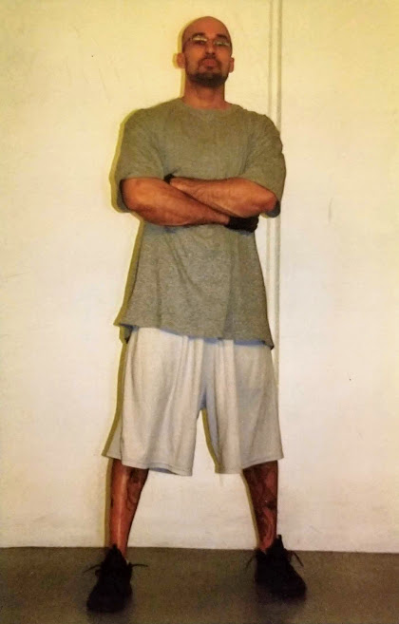

Peace and Blessings
