reachingaprisoner.com
Hello,

Jacob Spurlin DOC#12560-010 United States Penitentiary- Coleman P.O. Box 1034 Coleman, FL 33521
DOB: 5/9/1983
Gender: Male
Ethnic Background: Portuguese
Height: 6ft 2in
Weight: 200lbs.
Hair Color: Brown
Eye Color: Green
Expected Release: 4/2021
Sexual Orientation: Straight
Looking to Write: Woman
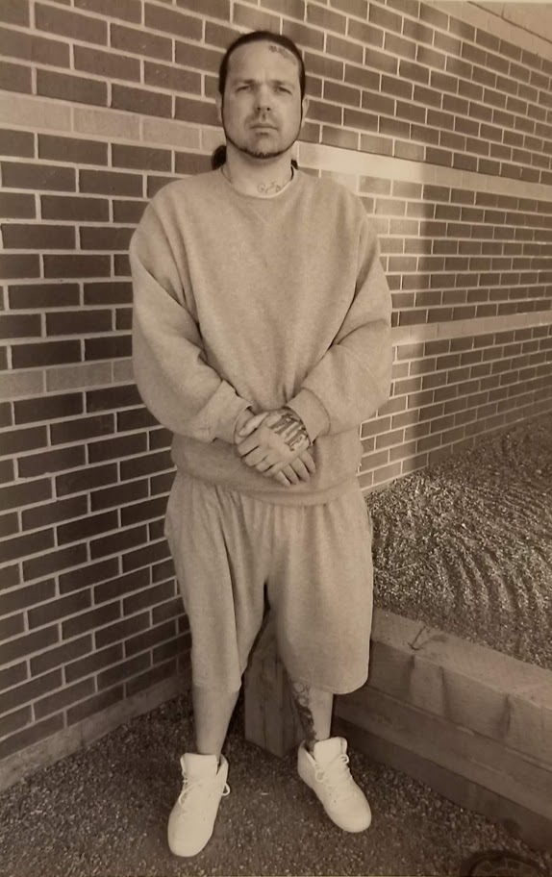

Thank you for taking the time to check out my profile. I’m on this site to try to meet new people. Meet some new friends, and with any luck- meet someone truly special.
I’ll tell you a little about myself: I grew up in California between Oakland and Modesto. When I get released, I will be going to Hot Springs, Arkansas, where I have family. I am a real family-oriented person. My family means the world to me. I enjoy boating, motorcycles, traveling, going to beaches to watch the waves, cooking, listening to music, shopping, and if I find the right person-cuddling by the fire. My music choices range from the Blues, 90’s, R&B, Rap, Classic Rock, or anything in between. I like good company and even better conversation.
I’m Portuguese, 6’2, 200Lbs, with a nice slim build. I have long curly brown hair, green eyes and some tattoos. My birthday is Mat 9th and I am Taurus. I don’t have any kids, but would love to have a few one day, with the right woman. I do have a West Siberian Laika, who is 5 ½ years old. She is beautiful and is 1 of only 200 registered here in the United States. She is my baby!
I went to college for Environmental Horticulture. I enjoy working with plants. I’m very open minded and willing to try almost anything once. I’d like to meet a smart, caring, funny, honest, openminded, career orientated woman. If you like anything or are intrigued by my profile get in touch. I would like to meet you.
I can email and I also have text service you can text messages too. You can also text photo’s but those take a little while to get to me. The messages get sent right to me. I look forward to hearing from you. Once again, thank you, for taking the time to check out my profile. If you want to email directly it is jspurlin0010@emailinterface.org
