reachingaprisoner.com
Hello,

Mitchell Morrow#B76693 Centralia Correctional Center P.O. Box 7711 Centralia, IL 62801
DOB: 5/6/1968
Status: Single
Incarcerated Since: 1994
Charge: Murder
Age: 51
Looking to Write: ANYONE
Expected Release: 2024

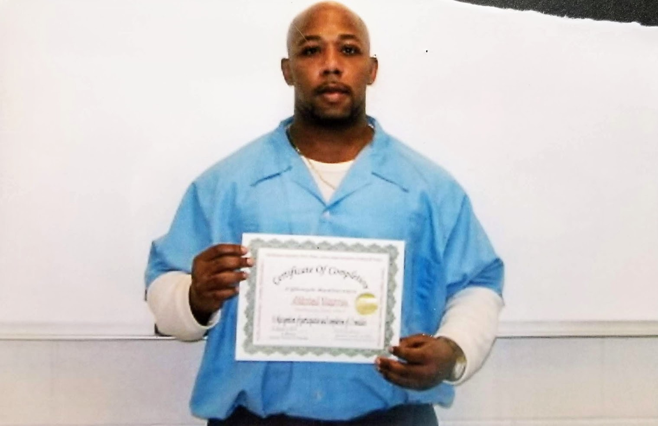

I am searching for someone to share thoughts, hopes, and dreams with. Someone who is open minded, thoughtful, fun, and caring. I am sure you will find all of these same qualities in me as well.
I am from Chicago, Illinois, but I have been incarcerated since 1994, so I’m ready to get out of here and start a new chapter in my life. I am into reading, learning new things, working out, and trying to stay fit for when I get back into the world.
I will be getting out soon!! I am hoping to have some new friends when that day comes. I have spent this time getting educated so that I’ll be fin in my body, mind and soul.
I am single, never been married, but hope to someday. I am still searching for that special someone. I am 51 with the drive and strength of a 21-year-old. Being here has preserved me in some ways.
I am ready to get out of here and see the world! So much has changed since I have been here. I would like to travel and visit new places.
Write me at my address to begin a new friendship. I will respond immediately. Send me your number and we can talk on the phone too. Facetime is done here also. I hope to hear from you.
Sincerely,
Mitch

