reachingaprisoner.com
Did you cry at the end of Toy Story 3? I did=) My favorite animals are puppies; any breed they are all just adorable. I like meeting new people and learning different cultures. Traveling around the world is something I want to do. I also want to be grounded and buy my own home. I am very family orientated. People have told me that I am a pillar or responsible one of the group. I am an organized person by nature. I like for things to be in place, but I have been living with a disorganized roommate, so I am flexible. I enjoy having fun, dancing, my favorite genre of music is R&B, Soul and Jazz. I enjoy trying new things, horseback riding is one of those “new things” I’ve tried, and I enjoy it. I have never been married, I have a had long-term relationship that did not work out, but I am a believer in marriage. Since I have been incarcerated, I am now a certified plumber, I am working towards a certification in owning and operating a business. I also hold one of the highest paid jobs in the prison. My true aspiration in life is to be a better person. To love and be loved, to live and do the right to the best of my ability. I’m looking to make new friends or find a genuine connection with that special someone who knows that might be you.

Katera Williams DOC# 314834 B32-10L Arizona State Prison Complex-Perryville San Pedro P.O. Box 3100 Goodyear, AZ 85338
DOB: 1/8/1990
Gender: Female
Ethnic Background: African American
Height: 5ft 6in
Weight: 180lbs.
Hair Color: Brown
Eye Color: Brown
Expected Release: 10/2020
Sexual Orientation: Bisexual
Looking to Write: ANYONE

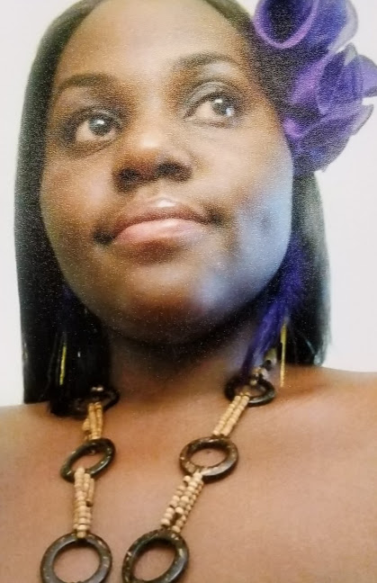

the tree of fire
by: Katera Williams

the tree comes to me
for the first time in weeks.
when did all its colors,
like some commerical for dying,
start shooting out of it’s skin?
this morning, we fucked
eachother into a regular
backyard bonfire-cold wood
turned to coal in the fine,
fine flame. and now, this tree
breaks into view, lurid red leaves
that demand a clanging,
screaming alarm, and I think-
this tree has been here
all this time, and I didn’t notice.
I swear, I’ll try harder not to
miss you as much: the tree, or how
your fingers under still
sleep-stunned sheets
coaxed all my colors back.

