reachingaprisoner.com
I’m from a small town outside of Knoxville, Tn. I love to shop, ride 4 wheelers, amusement parks and anything outside. I love to laugh and joke around and I have a sick sense of humor. I’m looking for friends that may lead to more. I’m open to relocating and love to travel! I hope we can share many laughs.
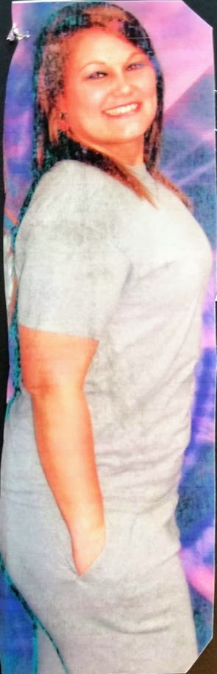
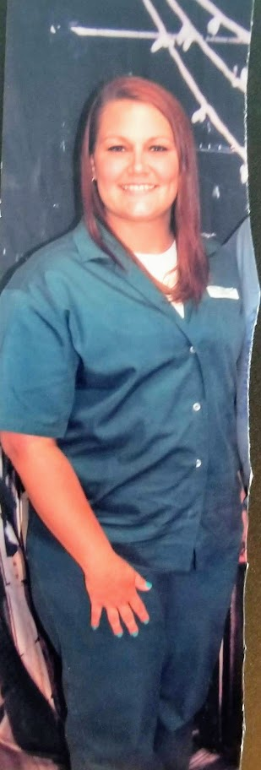

Lara Bolton DOC#45254-074 FCI Aliceville P.O. Box 4000 Aliceville, Al 37442
DOB: 1/5/1986
Gender: Female
Ethnic Background: White
Height: 5ft. 6in.
Weight: 170lbs.
Hair Color: Dark Brown
Eye Color: Green
Expected Release: 01/2020
Sexual Orientation: Lesbian
Looking to Write: Men, Woman, Straight, Gay/Lesbian, or Bisexual
