reachingaprisoner.com
-Congratulations-

Brandon Dunnagan-Merrill DOC#280793 Green River Correctional Complex 1200 River Road Center City, KY 42330
DOB: 9/12/1996
Gender: Male
Ethnic Background: White/Irish
Height: 6ft. 2in.
Weight: 200lbs.
Hair Color: Brown
Eye Color: Hazel
Expected Release: 2035
Sexual Orientation: Straight
Looking to Write: Woman
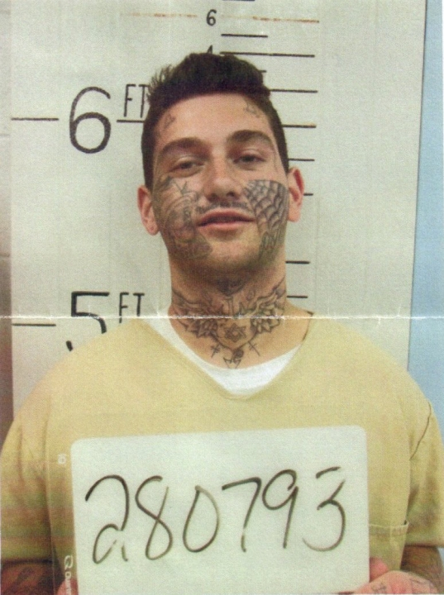

You’ve just came across what you’re looking for. Someone who’s different from the rest, a real man who’s not here to tell you lies and try and run the game. What I am here for is to hopefully connect and make a lasting solid friendship based off knowing each other for who we really are. What I do have to offer is respect, sincerity, loyalty, and consideration. I’ll always be here when you need to talk and being a good listener helps. I’m very open minded and down to earth person. I like spending my time hanging out with friends, working out, playing handball, or laid back watching tv. I am also a tattoo artist which is something I love to do and have a passion for. I like watching UFC (I’m a big Connor McGregor fan), The Walking Dead, Pit Bulls and Parolee’s, 90-Day Fiancé, Game of Thrones, and Rick and Morty. I like music of all kinds from Volbeat and Escape the Fate to Kevin Gates. My favorite movie probably would have to be Breaking Benjamin, though I’m currently in on a murder case and assault 2nd, which is in the process of hopefully being granted an appeal. I spent my childhood and teenage years going through foster homes, group homes, and bootcamps until I was adopted at 16. I graduated from high school; I also have a son. It’s easy to get lost in the system and lose focus on the outside world when you don’t really have much contact with people outside of prison. I’d like to change that. If I interest, you in anyway make sure to contact me threw JPay or snailmail. I look forward to hearing from you.
