reachingaprisoner.com

Jennifer Labbe DOC#331854 York Correctional Facility 201 W. Main St. Niantic, CT 06787
DOB: 12/5/7987
Gender: Female
Height: 5Ft. 8in.
Weight: 132Lbs.
Hair Color: Medium Brown
Eye Color: Honey
Expected Release: 1/2020
Sexual Orientation: Bi-Curious
Looking to Write: Straight Men
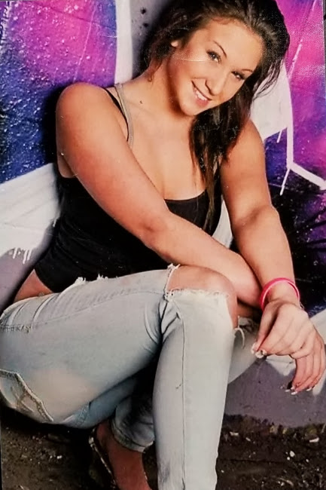

Hi Guys,
My name is Jennifer, but my friends call me “JoJo”. I’m a single lady in here with another year or so before release and I could use a little company to cheer me up and keep me occupied. I’ve elevated from previous mistakes and have made necessary changes in my life during this incarceration to ensure my success continues upon departure from YJC. Right now, I’m finishing up my very first semester of college with an A average in Business Management and I’m just as excited to begin next semester in January. Besides college, I sing, sew (as my full-time job), and write music in my free time. I believe in myself and my ability to write love songs that people can relate to, dance and sing to because they are catchy. I know with the right music behind my voice there’s a chance I can make it to the top. I would love to hear from a gentleman with the kind of passion for music whether, you sing, play an instrument or 2 step LOL or maybe you just like to listen to music or go to a concert, that’s fine too! I like adventure too (I’m a Sag.) So, I pair up well with men who can hold my attention and is interesting like me because my personality is but not conceited like. I read my horoscope sign is most compatible with Fire and air signs like a fellow Sagittarius, Aries, Leo’s and Libra’s for example. I am however, open-minded to other signs.
I love to cook for a man that likes a good home cooked meal. I want to satisfy my future man’s appetite before bed, so he’ll always want to come home to me and no miscellaneous woman.
Well as for books I mostly just read magazines like Cosmopolitan, Glamor, Martha Stewart, and stuff like that. But mostly I just look at the pictures and hang them up, even though later on have to obey the authorities here and take the celebrity’s beautiful and luxurious pictures off my wall.
If your interested in getting to know me, I’d like to hear from you. Please if you write, do so on a serious note because I am going to be 31 on December 5th and don’t want any “fake news responses” just sincerity.
Thanks for your time and future honesty when responding!
Sincerest Love,
Jennifer

