Reachingaprisoner.com
Hi!

Oscar Villatoro DOC#08801-007 FCI Bennettsville P.O. Box 52020 Bennettsville, SC 29512
DOB: 5/29/1979
Gender: Male
Height: 5ft. 5in.
Weight: 155lbs.
Hair Color: Black
Eye Color: Green
Can speak and write Spanish
Expected Release: 2021
Looking to write: Woman
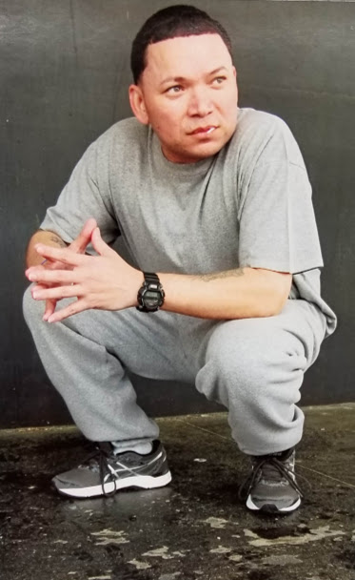

My name is “Oscar”, if I were to describe myself as a person, I’d say good-hearted, family oriented, honest, respectfully, loving, funny, and down to earth.
My hobbies are working out, playing sports, reading, watching movies, and writing poetry.
I am looking to meet a woman who is interested in good conversation, someone who would enjoy a positive and fun personality and a good listener. A person who shares some of the same qualities and has a desire to build a lifelong relationship. I don’t mind if a woman has kids.
I don’t have a typical preference in beauty. Your ethnic background, age and location does not matter. I want an optimistic and good spirted personality. I respect the inner beauty of a woman and the gift of true friendship.
Thank you for your time. I look forward to receiving your letters and I do have access to emails.
I going to close this with nothing but faith, love, and respect.
“Oscar”
I want to share a poem with you.
Reflection is Love
I look at me as I see me
so clear as the mirror cannot lie.
I find me as I love me and
this truth cannot hide.

I clean me as I clear
the mirror because my eyes
see my weaknesses and my pride.
I love the world as the blood runs
Through us all as “one”.
