reachingaprisoner.com
Hello,

Tommy Slaughter DOC# 18150-033 USP/Hazelton P.O. Box 2000 Bruceton Mills, WV 26525
DOB: 6/29/1991
Gender: Male
Ethnic Background: Black
Height; 5ft. 10in.
Weight: 200lbs.
Hair Color: Black
Eye Color: Brown
Expected Release: 2029
Sexual Orientation: Straight
Looking to Write: Woman

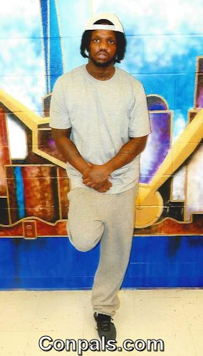

My name is Tommy, and I’m a cancer. I’m looking for a friend, because I believe you can build something beautiful, and strong with that foundation. I have a great sense of humor, so I enjoy laughing as much as making people laugh. I’m the type of man who will tell you what you need to know, not what you need to hear, so if real is what you want desire, it’s right here. I’m the type of man who stands on everything I say. I’m the type of man who’d rather show than tell. I’ma give you me, not just some fairytale. I respect and value a woman’s mind, body, and spirit. I feel that a man and a woman on the same wave can complete and make each other better. I’ve experienced a lot in life and I’m looking to share these experiences with, along with whatever else life brings along I am looking for someone kind, motivated, and very loving, because I am all of those, and more. I am not judgmental person. I appreciate physical beauty, but value what’s on the inside more. I enjoy the journey that is getting to know someone, as well as them getting to know me. I like to pass time eating (LOL!), reading books, playing basketball, working out, having good conversations and experiencing new things. I really enjoy doing things with a female companion, someone I can create fond memories with and a bright future. I’m not a perfect man, but I’m perfectly honest and that alone will separate me from 95% of the people you will meet. My only motive is something solid and real. I accept people for who they are as long as they are honest, I don’t ask for more than I am willing to give. Love has left me with a lot of questions, so I’m searching for a woman that can provide me with the answer. If you like what you read hit me up.

I’m Ready
I’m ready to settle down, but latelty hard times
and heartache is all I’ve found.

I’m ready to find someone I can trust, someone who wont fall victim to lust. Someone who is all about “us”. A love that won’t rust because we stay shaking the dust.

I’m ready for the stability, and a woman who isn’t afriad to be loved because I have the ability to light her up like a utility.

I’m ready for someone that the old school love songs spoke about, a woman what I don’t have to doubt, because I’m tired of going that route.

I’m ready to give love antoher try, ready to meet someone who doesn’t feel they have to lie to get by, because you can tell me you faults, and I’ll understand why. I need a woman who is down to ride, hold the wheel steady because
I’m Ready.

I’m Looking
I’m looking for someone that I can give my heart
And soul to. Make her my goal too.

I’m looking for something that many have been overlooked,
If that flight hasn’t been booked.

I’m looking for a beautiful heart, because a lot of people forgot that part, but it’s where I start, because loving another person is an art.

I’m looking for something real, and lasting, and I’m also looking
to give what I’m asking.

I’m looking for something that I haven’t been able to find,
Someone to give me a sound piece of mind, someone I can show that side of me that is kind.

I’m looking for something I haven’t laid eyes on yet, a winner, a sure bet, a woman that is as good as they get, a woman I haven’t met.

BECAUSE I’M DEFINATLEY LOOKING!!!!!!!!!

