reachingaprisoner.com
Hello,

Chaske McDonugh DOC#07696 Mike Durfee State Penitentiary 1412 Wood Street Springfield, SD 57062
DOB: 10/22/1981
Gender: Male
Ethnic Background: Caucasian
Height: 5ft 9in
Weight: 175lbs.
Hair Color: Brown
Eye Color: Brown
Expected Release: 11/27/2031
Sexual Orientation: Straight
Looking to Write: Anyone, Woman
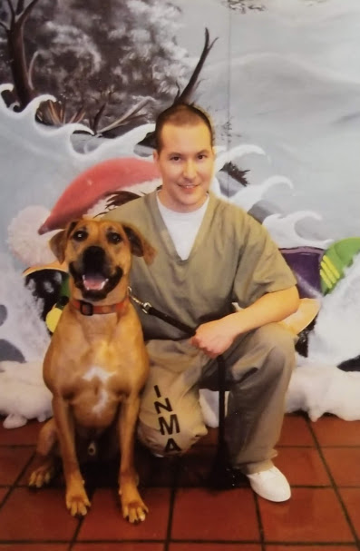

I’ve been in prison for a while now. I’m looking for positive people to surround myself with and get to know. After I cam to prison, most of my people fell off that includes “friends” and family. That’s fine though, because I’m looking for new beginnings, new faces, and new friends.
I’ve always been a very loyal and honest person. If you were to ask me what my best attributes are, I’d say honesty and loyalty. I’m also very protective over the ones that I love and care about. I don’t like drama and I don’t like stress. You will find I’m a fun-loving person, but I know when to be serious. Don’t worry, I promise I don’t bite. (Jokes)
As you know, I have made some mistakes in my life, but that doesn’t define me as a person. Everyone makes mistakes, it’s just some are worse than others. I hop that now that you’re interested in getting to know me as a person and as a friend. If that’s the case, shoot me a letter or message me directly at connectnetwork.com website, this will walk you through the whole process of signing up and creating an account, adding me as a contact, creating an email address specifically for this site, them getting conformation to message me on my tablet. You’ll need a debit or credit card to purchase debit links to send and receive messages and photo attachments which costs .25 cents each. I see everyone around me receiving mail and photos and messages on their tablets, it would be great for me to receive any of this.
Apart from making Native American jewelry and beadwork I’ve been under the music section on my tablet listening to various music and their cultures. I am fascinated by some of the Bosnian, Russian, Celtic, and Spanish speaking cultures featured on there.
Make sure your letters are on plain white notebook paper, white envelopes or typed on the computer. Tape, stickers, postcards/greeting cards, perfume, and sticky address labels are not allowed.
Looking forward to receiving your letters, messages, and photos soon.
