reachingaprisoner.com
Hello, my name is Christine Paige Hartoon, a single mother of two great kids. My son is 22 and married and my daughter is 14 and my mother has her. My family stands beside me through all of this. My past has been hard the last ten years, but my life has changed dramatically since my incarceration this time. They have denied my parole and I see them again in 12/2019. I max out 3/8/2020.

Christene P. Hartoon DOC#2184186 Lockhart Unit 3A-211 1400 Industrial Blvd. Lockhart, TX 78644
DOB: 5/23/1973
Gender: Female
Ethnic Background: Caucasian
Height: 5ft 8in
Weight: 172lbs
Hair Color: Red (Auburn)
Eye Color: Green
Expected Release: 3/8/2020
Sexual Orientation: Heterosexual
Looking to Write: ANYONE
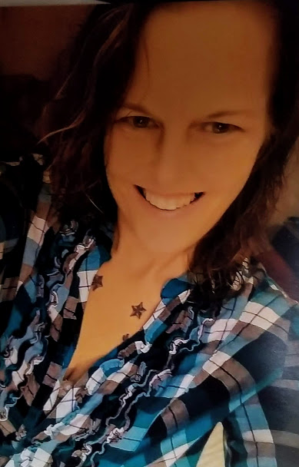

Things I enjoy when I’m out; riding Harley’s and horses. I love to dance, cook and bake. The beach is my second home. I enjoy spur of the moment trips, but also enjoy planned ones as well. I love to go camping, fishing and yes, I will bait my own hook and take the fish off and clean him. I’m a country girl through and through, but I enjoy some rock n roll old and new. I don’t believe I look my age either, 45 years young! Never been married.
I don’t do drama inside or out of prison. I live a simple life. I’m so looking for friends who knows what may have or may not have happen. I really enjoy being cuddled up on a couch on a rainy-day watching movies.
Some of the things I have accomplished since being locked up. I’ve taken four computer classes, well 4 in 1 called BCIS. I am currently taking a printing and imaging class for five more months. I also do a knitting hearts class every other Sunday. We make blankets for babies and elderly. I’m also in a Get Real class once a week an I’m currently waiting to see if I can get into a dorm for PEP. Business dorm that will show us the ropes to starting our own business and the faith-based
dorm. I’m also awaiting acceptance to the set-up crew. That’s were we set up for anything that goes on here.
That’s enough for now, I hope to hear from you soon.

