reachingaprisoner.com
Hi, Thanks for stopping to read this, hopefully your well, and I can add a smile to your face.

Jacob C. Perez DOC#P-45297 Kern Valley State Prison D-5-203 P.O. Box 5104 Delano, CA 93216
DOB: 6/2/1980
Gender: Male
Ethnic Background: Chicano
Height: 6ft
Weight: 175lbs.
Hair Color: Black
Eye Color: Brown
Expected Release: 1/17/2022
Sexual Orientation: Straight
Looking to Write: ANYONE
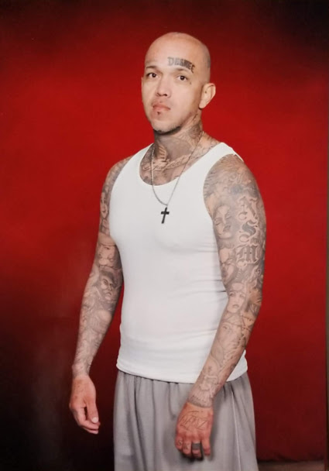

I’m Jacob and if your looking for conversation, friendship, laughs, and possibly more, I got you. I have a colorful history, heart of gold, and thirst for life. I’m a published poet, songwriter, and author. I’m looking for someone to learn from, laugh with and maybe explore something brand new with me, guaranteed never a dull moment.
Here’s something I’m working on: “If I ever fall in love again, bet I won’t do it like before/won’t mess things up, won’t fall face first on the floor/ won’t shut her out, nah, bet I’d listen to that girl/make her my world, my one and only /Introduce her to mom, she’d be my lady, lover and homie, never phony/ lock me down ma, she’s own me/ Like her favorite pair of heels, or a donut near a fat boy/ I’d never piss her off, never lever her annoyed/ live above the clouds, give her bliss ecstasy and joy/ all she can handle, double that and more/ more than she thought of, or dreamed of before/ I got us ‘cause I was born to soar/ so when I find her I’ma put her on my back, like a backpack, and we’re gonna take flight/ light the fuse ma, be the sun in my sky /smile, say you’re ready to do this right/ shine bright, wear a crown and take over the world/ are you precious one, my 24k gold…
What do you think? Hopefully you liked it, or one of the others I’ve included. I’d like to hear your thoughts on them, or anything else you’d like to talk about it.
Tell me about what makes you tick, and what makes you, you. I’m looking to meet someone to laugh and smile with as friends and maybe more. I’m open to the possibilities and hope you are too. I’m looking forward hearing from you, until then and always take care.
Always,
Jacob ‘Crow’ Perez
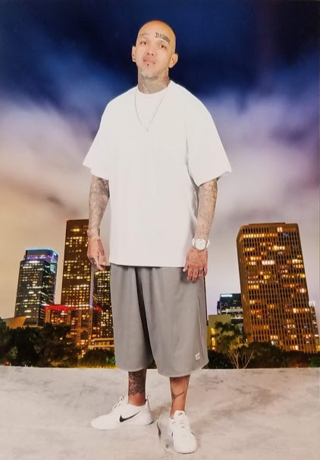

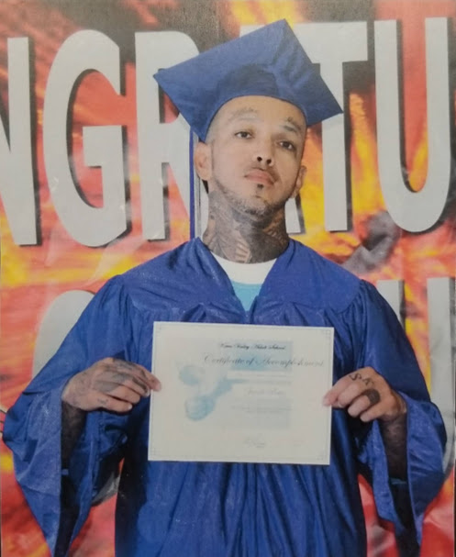
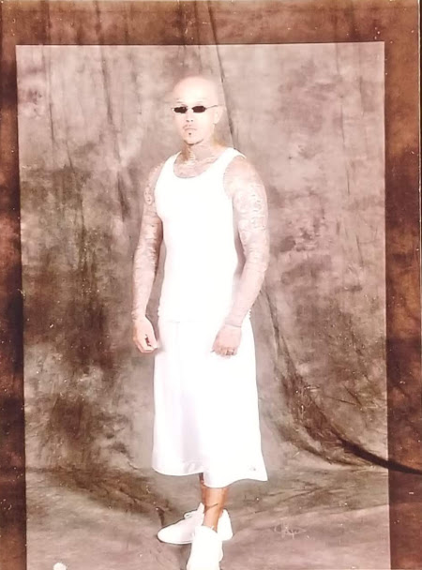

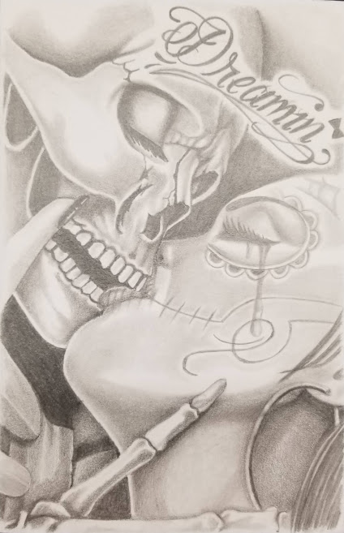
‘2700’
2700, on me, I’ll die for it
2 pieces in the sky, i’ll ride for it
with hand on bible, better believe i‘ll , we for it
and whether black, red, or wet, baby i’ll cry for it
all my life, i’ma shine for it
sacrafice and grind for it
24/7, 365, all my time for it
even nametag 9 to 5 for it
and call to duty, I’m serve fot it
Yeah, on 2/7/00, everything changes
down came my princess, and nothing was the same
the wild and lawless was about to be tamed
my boys call me crow, but my daughter changed my name
a father and provider, business is my thing
if it ain’t about her, get it out of my face
‘cause Desi’s my heart, yeah, she’s my ace

“Only Want You”
Ma, you gotta quit talking ‘bout “basic”
You’re my Queen, my bad chick
They average, your spaceship
You’re louis, and the payless,
And I treat you like Paps do famous,
I’m a God, call me Satan,
You claim I’m complicated,
Then scream I’m the greatest,
But baby to me it all sounds like the same SHHH!
So, embrace it. I’m tameless,
I push buttons, you hate it,
Then you test, and I ace it,
I’m the best, the rest nameless,
So, come here, love me daily,
I only want you, Oh yes Baby,
Mow Ma, my life will never be saintly,
We’ll live on the edge daily,
I only want you, oh yes baby,
Now Ma, my life will never be saintly,
We’ll live on the daily,
But I’ll be exciting, earth shaking,
While others sit around daydreaming,
Waiting, wanting and fencing,
We’ll have ecstasy, deeper meaning,
Come with me, be my reason,
I only want you, sincerely.

Dreaming of you

At night I close my eyes and live life with you
I’d evict the sun from the sky just to have more time with you
Everything I need to be, simply put, Y-O-U
Baby you got what I need to succeed and go places
Have me rubbing elbows with CEO’s, making big faces
Go to Vegas, guaranteed to turn up all aces
Lace it up, I’ll put the world in a bow for you
Then double it up like Noah and give you two
True to mu=y work, so watch me come through
Ooh, you and I, we’re gonna make a run at forever
Loving life and dreaming together
Never wanting, never
And whether rain or shine, I’ll be my best for you
Being the man I am, doing what I do
So why don’t you exit my head and be my dream come true.

“Trust” by: Jacob “Crow” Perez
Ma, you know I’ve seen and done a lot in my life
Been quite a few things, ain’t always been nice
Always did things wrong, before I ever did right
And time heal wounds, but my scars live in plain sight
And I’ve:
Been there, done that
Pushed weight, popped caps
Drew blood, they held mass
And done time, walking my path
I push hard, won’t fall back
Got scars, tat’d back
And broke hearts, got broke back
And chased ghosts, they ran fast
Now that is, the past
I say this, I say that
Trust me, I’ll trust back
‘Cause I want you, That’s fact
So let’s do this, let’s have at it
Take deep breaths, like asthmatics
I can love you, be good at it
So, drop fear, like bad habits
I’ll be great, fantastic
So trust me
I’ll trust you
We’ll trust us
And be happy!

“That One”
….crafted in my dreams,
You’re simply flawless prefection,
everything that i need,
You’re that sweet tasting, confection,
all that and more,
You’re my angelic blessingd from heaven,
now lessen the pressure,
come through and materialize at my side,
share my world,
be the meaning of life,
my fountian of youth,
24/7, 365,
gice me what i need,
to push forward, succeed and thrive
‘cause I’ve been the world,
and know what i need,
SO, take heed and believe,
no other could cuff, ring or please me,
sincerely, i’ve only had a dream,
about that one,
that can truly br my everything,
yeah, everything I need,
one word: you,
nobody compares,
no other will do,
true to my word,
you got me feeling brand new,
SO, do what you do,
come be my dream come true….

