reachingaprisoner.com

Randall M. Minor DOC#64362 Limon Correctional Facility 49030 State Hwy. 71 South Limon, CO 80826
DOB: 6/16/1965
Gender: Male
Ethnic Background: Mixed
Height: 5ft. 8in.
Weight: 225lbs.
Hair Color: Brown
Eye Color: Brown
Expected Release: March 2020
Looking to Write: Woman, Bisexual
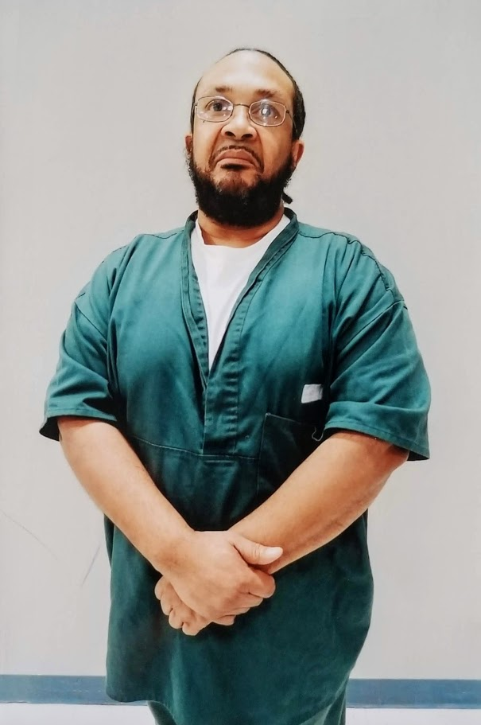

I’m seeking a sincere, confident, loving and strong woman who wants a friend, companion, mate and strong provider. I’m not one to play games and I don’t want a woman who plays games or who is into dramatic nonsense. I’m an honest, truthful, and excellent provider and there is nothing I will not do to make sure my woman has everything she needs or wants and that is the same quality I want in a woman. At this point in time I would like to take this opportunity to get to know someone mentally and emotionally and for her to get to know me the same way before we meet in person. I don’t want a self-centered narcissist who into using people to get along in life, I need someone that is loyal, truthful, loving and open to wanting a man who will treat her with respect, kindness and dedication. I enjoy reading, listening, to music, watching movies, camping, fishing, hunting, hiking, working on cars, studying the law and doing what it takes to make my woman happy. I’m in prison for felony menacing, assault, and child abuse. I got these charges for stopping someone from killing me who stabbed me 5 times and I took the knife from them so I was charged with menacing and assault and while this was transpiring there was a child present so I was charged with child abuse due to the kids being in the house. I’ve done my sentence day for day and I’m due to get out next year with no parole. When I get out, I want to take a special friend I have met on a nice romantic cruise or trip somewhere so we can get more acquainted with one another. Being the resilient man that I am Leaves me optimistic that I will meet a woman who wants a loyal, honest, supportive, caring, appreciated, and loving man who will provide, protect and take care of her like a man is supposed to do. I’m a real man.

