reachingaprisoner.com

Randy Stevens DOC#N80887 Menard C.C. P.O. Box 1000 Menard, IL 62259
DOB: 4/22/1970
Gender: Male
Race: White
Height: 5ft 10in
Weight: 160Lbs.
Hair Color: Black
Eye Color: Brown
Life
Willing to Write: Anyone
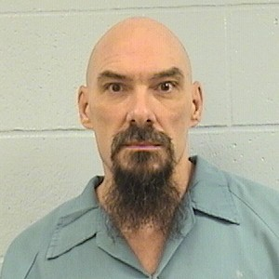

Greetings to all who have stopped to check out my ad. PLEASE EXCUSE MY PHOTO! It’s the only one I have. Just remember your own driver’s license photo’s. HAHAHA! I’m much happier than my photo conveys, and I have a good heart too. I’m hoping that I’ll be able to reach out and start a friendship with someone willing to give me a chance. I’ve been locked up for 26 straight years and I’ve been lonely for many of them. Most of my family has passed away and the few left have forgotten me. Needless to say, making new friends and receiving letters at mail call would be a joyous occasion and would help me escape this dreary prison for a while.
Some things I am interested in are Nascar and football; GO COWBOYS!! I also enjoy working on cars, although its been a couple of years since I was the mechanic in another prison; working on all types of state cars and trucks. I now enjoy working on tv’s, radios, and just about anything else that can electrocute me. HAHAHA!
I like all kinds of music, books, Sudoku, puzzles, and mind-benders. I like action/comedy movies and tv programs. I’m caring, giving and I have a good sense of humor. I’m looking for anyone who’s honest and willing to commit to a friendship. I’ve got a very long sentence, so I would like our friendship to be long term also.
I’ll respond to any/all letters. If your overseas, please only write if you are truly serious about a friendship. Postage is expensive for Airmail, as I’m sure you are aware. So please reach out and know you’ve put a smile on my face. Wishing you all the best, and I’m looking forward to hearing from you.

