reachingaprisoner.com
I am from Lubbock, Tx. I have lived in other towns and states, but Lubbock is home.

Patricia Hernandez-Salas#56489-177 FCI- Aliceville P.O. Box 4000 Aliceville, Al 35442
DOB: 5/29/1969
Gender: Female
Ethnic Background: Hispanic
Height: 5ft 6in.
Weight: 183lbs.
Hair Color: Black
Eye Color: Brown
Expected Release: 11/11/2023
Sexual Orientation: Bisexual
Looking to Write: ANYONE
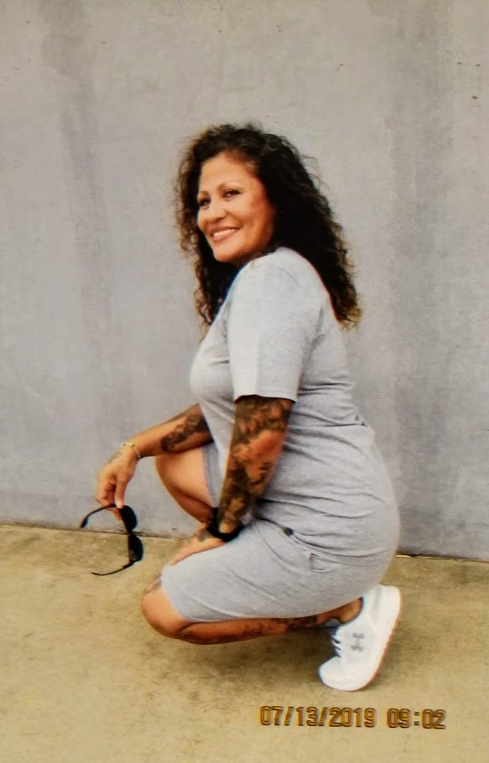

I love God and Life. I like to travel, go to casino’s swim, draw, read, shop, do hair, and go to church.
Love, love, love to cook, bake and clean.
I’m the clown of the family. I keep people laughing and happy. If I can help someone out I will.
Very humble, caring, loyal with a good sense of humor.
Looking to make new friends and open to a relationship if it comes to that. Relocating is optional. Can’t wait to meet you!
