reachingaprisoner.com

Gerardo Martinez DOC#1262425 Stiles Unit 3060 FM 3514 Beaumont, Tx 77705
DOB: 4/9/77
Gender: Male
Ethnic Background: Hispanic
Height: 5ft 8in
Eye Color: Hazel
Speaks and Writes: Spanish and English
Expected Release: Soon
Sexual Orientation: Straight
Looking to Write: Anyone
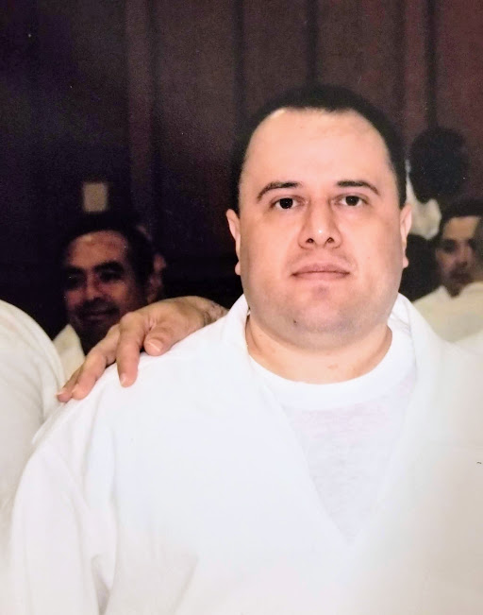

Hola,
I hope this letter can bring a smile to somebody. I’m looking for someone that I can share my friendship with. I like to smile, dance, work out, read books, listen to music and cook. I want to learn from the world because I have been locked up for 15 years, and I’m waiting right now to go back to trial, so I want to be ready. I have an open mind for new things and new friendships. I hope I can find the right person to share my happiness when I get out of these prison walls.
Gerardo

