reachingaprisonercom

Dale E. Flanagan DOC# 0021853 ESP P.O. Box 1989 Ely, NV 89301
DOB: 8/13/1965
Gender: Male
Ethnic Background: German/Irish
Height: 6ft 1in
Weight: 170 Lbs.
Hair Color: Brown
Eye Color: Green
Speaks: English and German
Expected Release: 4/1/2019-2020
Sexual Orientation: Straight
Looking to Write: Anyone
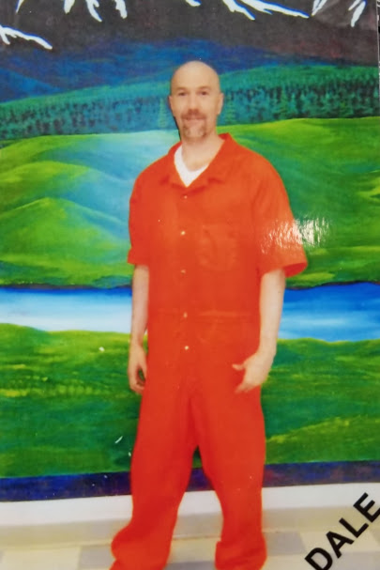

As I dig for wild orchards in autumn fields…it’s the deeply bedded root that I desire, not the flower.
There’s a saying about finding an incredible treasure in a field you do not own, going and selling all you have to buy that field.
I’m tired of fool’s gold.
Life should be more than an endless blur of up at dawn; work, eat, sleep, repeat. We all deserve someone solid, enduring, you feel a sense of connection with, who see’s you in a way you only imagined someone would…I am not seeking your favorite color. I want to know you, the genuine hair down w/o censor you. Are you brave enough? I receive plenty of responses, but I seek real friends, not acquaintances. Is that you? A door stands open.
Warning!! =) Not for the shy, but all in good fun.
A bit about myself. I am passionate and serious about the right things in life, hands on in work and play. I have a Masters in Theology, love to ride horses and Motorcycles, play with my dog, to explore…I practice Martial Arts, teach yoga, am open, direct, playful, warm, enjoy British Premiere League Soccer, formula one racing, ice hockey, UFC…I do tell a rude joke or two. “How did Pinocchio discover he was made of wood?”
Write, lets get together, enjoy what we will find, what we have in common and perhaps more interesting, explore our differences.
Walking with a friend in the dark is better than walking alone in the light.
I look forward to our first. (Please no one under 21)
Canada and overseas (Ich lese Deutsch sehr gut, schreibe enigermassen) please write through www.jmail.cc. In the states www.corrlinks.com Always include you snail mail address.
I left the poetry section blank. Poetry for me claws it’s way out of extremes of emotion. That, I would not share with just everyone. As we get to know each other……I would
Dale
