reachingaprisoner.com
Hey You!

Aaron Felty DOC# 252854 Eastern Kentucky Corr. Complex 5-BU-7 200 Road to Justice West Liberty, KY 41472
DOB: 6/3/1992
Gender: Male
Ethnic Background: Mexican/White
Height: 5Ft 6In
Weight: 180lbs.
Hair Color: Black
Eye Color: Brown
Expected Release: 2021
Sexual Orientation: Open
Willing to Write: ANYONE
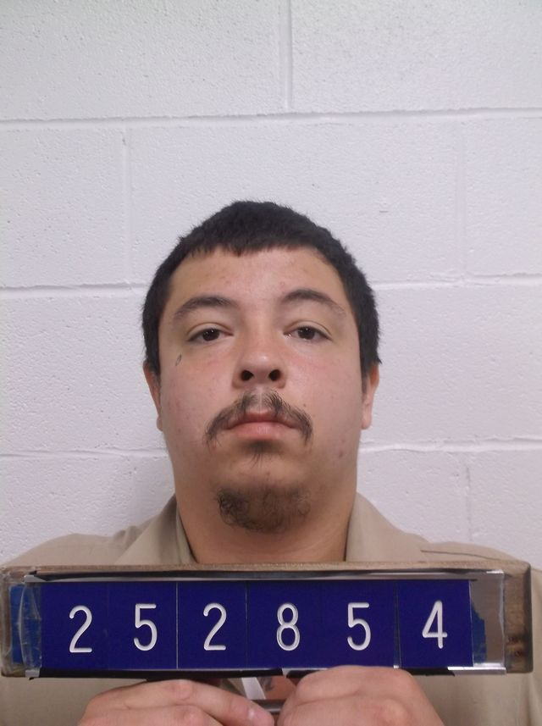

Hi, my name is Aaron Felty!
I am 26 years old, half Mexican and half white! I am 5 foot 6 inches tall, 180 pounds. Very Athletic! I’m lighted skinned with short hair and I have tattoo’s all over! I’m currently serving a 10-year sentence for Burglary. If I had to best describe myself, I would say that I’m very ambitious, loving, and fun to be around because I love to make others laugh ang just have a good time! I love to work out and play basketball! I also love to dance and read books! I’m more of a true crime geek than anything! I love music, all types, but mostly I listen to rap and R&B! I’m born in and raised in Kentucky, but I’ve never left so traveling would have to be at the top of my list of things to do once I’ve finished up with my time here! I’m working on my GED! My next step is to get a college education while I’m in here! I’m looking for someone who’s smart, funny, and adventurous, Ambition, open-minded and accepting! I don’t really have a specific type, so don’t be shy. I’m very open! So, if you like what you hear and like what you see and don’t mind meeting someone new, I would love to hear from you! I can be reached at this mailing address! Or on JPay!
