reachingaprisoner.com
Dear Potential Responder;

Mitchell Scott Simpson DOC#86438 North Central Unit 10 Prison Circle Calico Rock, Arkansas 72519
DOB: 2/17/1967
Gender: Male
Ethnic Background: Caucasian
Height: 6ft. 0in.
Weight: 210lbs.
Hair Color: Dark
Eye Color: Hazel
Sexual Orientation: Heterosexual
Looking to Write: WOMAN
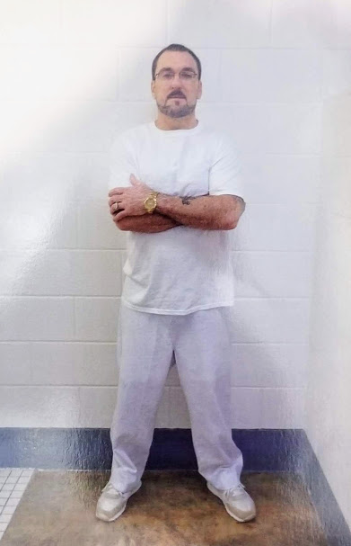

My name is Mitchell (Mitch) Simpson. And I’m currently incarcerated in Arkansas Department of Corrections. I’m currently seeking a friend that understands my situation. My intentions, and good faith is to meet an angel. I have the desire o meet new people and not associate with the ill minded, (old friends), in doing so this will advance my progress toward success. It was once said, that the most common cause of failure is the habit of quitting when one is overtaken by temporary defeat. I’m ready for change, and I know times may get difficult, but my desire for change is definite. Here in the next 14 months I will be transitioning from this environment, (incarceration) back into society. In the meantime, I’m seeking a genuine friend, one that understands, has an open-mind, great sense of humor and a willing heart. I hope that my efforts are not in vein in attempt to meet someone to be a part of this successful journey. Keep in mind that all who succeed in life get off to a bad start and pass through many heart breaking struggles before they “arrive” at the turning point in the lives of those succeed, it usually comes at the moment of some crisis, through which they are introduced to their “other selves”….. The other me has been through struggles as well as life enduring pains, with understanding that other people have been down that same path. Some just reach their turning point before others do… My mind is now set on success…with that being said, let me reveal a little information about myself…
Background: I was born in a small town of Huntsville, Arkansas, lived in Rio Grande Valley, Harlingen, Texas, South Padre Island for several years and moved back home, Fayetteville, Arkansas. I’m the 11th sign of the Zodiac in astrology, an Aquarius….
What I like to do: I love the outdoors, sunsets, hikes, fishing, floating rivers, long drives, listening to music, the list goes on and on. My mind is open to new adventure as well as the things that my significant other likes to do….
Books: I don’t do a lot of reading, when I do I enjoy reading James Patterson, Lee Childs as well as John Sanford….
Music: I listen to all types of music, depending on the mood, place and circumstances.
Accomplishments while behind this wall: I’ve taken a lot of programs, plumbing, thinking errors, parenting classes, substance abuse treatment program and a few more…
People I’d like to meet: Sincere, positive, outgoing, adventurous, understanding, successful, nonjudgmental, loving kind and relaxed.
With that being said, I’ll leave room for your questions… Feel free to ask any and all questions with the understanding that you will receive an honest answer…There are a wide range of opportunities in life, honesty being one of them, along with the adventure with a man behind bars,, it could be a journey that has endless possibilities…
Note: If you write or type me a letter, I can only receive three (3) pages, One (1) page front and back and one (1) page just the front, if not they will return to sender. Hope to hear from you soon.
Mitchell

