reachingaprisoner.com
Hello! My name is Joe. I’m from Fresno California, born and raised. I like to read and write. I love all types of music; R&B, Country, Rap, Hip Hop, Alternative. I am enrolled in College, going for my AA in business and I’m working on myself and changing all of my old ways. I am a very good listener, love to conversate and laugh.

Joe Sanchez DOC#AR6017 Desert View-MCCF (A-3-50) P.O. Box 970 Adelanto, CA 92301
DOB: 3/15/1978
Gender: Male
Ethnic Background: Mexican/Native
Weight: 150lbs
Height: 5ft 5in
Hair Color: Black
Eye Color: Brown
Speaks and Write Spanish
Expected Release: 6/20/2024
Sexual Orientation: Straight
Looking to Write: Anyone, Female, Bisexual
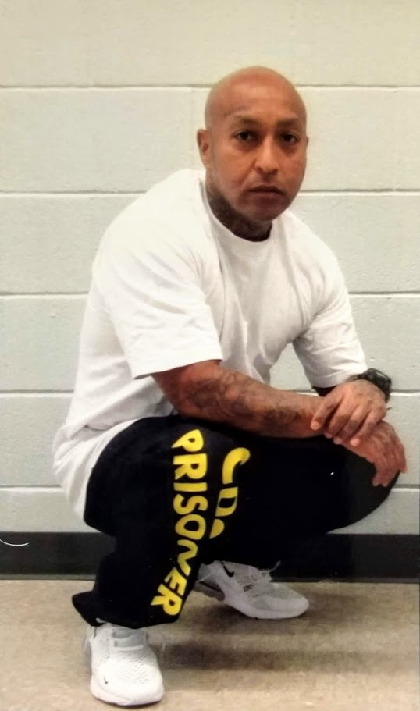

I am looking for someone who is caring, loving, with a beautiful smile, and a bright personality. A woman who has determination and passion. Someone who is easy to talk to and who won’t judge me on the mistakes I’ve made in the past. I believe there is someone for everyone, and I have faith one day I’ll find mine. I the process of that search I ma open to meeting new friends who like to write and wouldn’t mind getting to know someone like myself. I can also be a great friend and companion. There is a whole lot more to me, so if you decide to reach out to me. We can begin by getting to know each other.
Sincerely,
Joe Sanchez

