reachingaprisoner.com
Hello?!

Steve Mendez DOC#15A4407 Southport (B-8-7) P.O. Box 2000 Pine City, Ny 14871
DOB: 10/22/1994
Gender: Male
Ethnic Background: Hispanic
Height: 5ft 7in
Weight: 157lbs.
Hair Color: Black
Eye Color: Brown
Speaks and Writes Spanish
Expected Release: 9/20/2019
Sexual Orientation: Straight
Looking to Write: Straight Woman
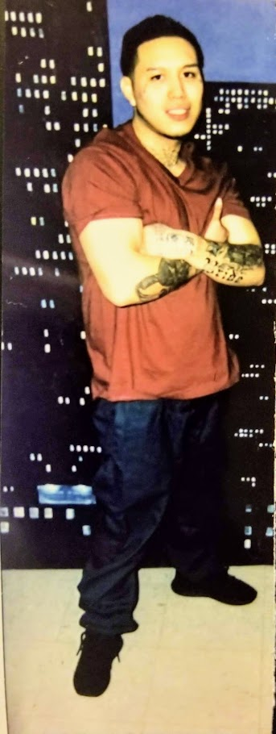

If you are reading this ad, then you must be open-minded or at least curious about who I am? That’s a good question? I’m a different person than I was yesterday. I would like to say thank you for taking the time to read about me! Here’s a little more insight to me!.....
My name is Steve Anthony Mendez, I’m 24 years old, Born October 22nd, Libra, Raised in the Bronx, New York. I’m currently finishing my G.E.D. and plan to continue my education to obtain my degree in Business Administration and Music engineering.
My hobbies are; writing music, such as love, reggaeton, trap, and romantic, weightlifting, studying the music business, drawing, dancing, cooking, swimming and traveling, living life, as adventurous as possible. My passion is expressing life in art and music form. That’s why I have tattoos and write music to represent different periods of my life.
I enjoy various genre of music, depending on the mood I’m in such as; R&B, Soul, Bachata, Reggaeton, Trap, Hip-Hop and Punk Rock.
My future goals are to get out of here with an education and be a better man, becoming successful businessman in music and a counselor for young adults. I will share my experiences to help children face their emotional issues. Open a program for children and a Club.
I’m placing my ad in hopes of finding a true friend and maybe a special someone to share my dreams, hopes, fear, and goals with. I would like to experience friendship and love, if it’s possible. If you can find it in your heart to be a friend or that special one, I promise you won’t regret your decision.
Anyways, there’s a little more about myself. How about you? I’m just looking to meet a friend or a special someone to toss some thoughts and letters back and forth with. If I sound like someone you might like to know, no subjects or thoughts are taboo, open minds are a blessing!!!!
I’m out!! Hope to hear from you soon!! I’m only a stamp away!!
