reachingaprisoner.com
Hello,

Travontay Johnson DOC#K18361 R.J.D (A-4-135 up) P.O. Box 799004 San Diego, CA 92179
DOB: 12/13/1985
Gender: Male
Ethnic Background: Black
Height: 5ft 9in
Weight: 170lbs.
Hair Color: Black
Eye Color: Brown
Expected Release: 10/10/2025
Sexual Orientation: Gay
Looking to Write: Anyone, Male, Gay/Lesbian, Bisexual, Transgender/Transsexual
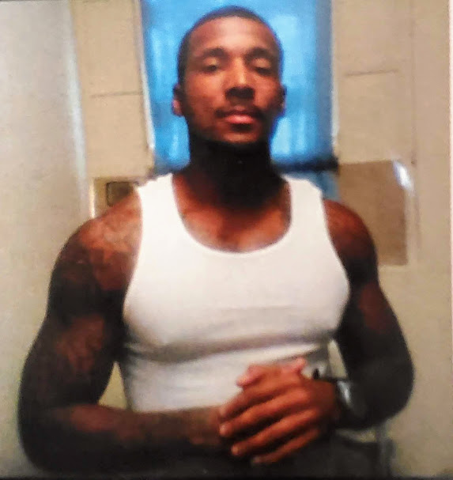

Beauty comes in many forms and someone wiser than I wrote that.” Beauty is in the eye of the beholder”, I never knew what that actually meant until a few months ago, when I began to write this ad. I hope your heart behold the beauty of my unspoken words that’s so tender, so caring, so loving…..
My name is Travontay Johnson, I’m 35 years of age, 5’ 9”, 170 pounds, single, and open-minded loyal and compassionate. I’m seeking someone well-seasoned that I could get to know and become the very best of friends or maybe more.
My hobbies are reading, writing poetry, music, working out and learning about life, as well as getting to know people from all walks of life. I am not about any mind-games and I believe in taking a chance for a change. I’m a positive thinker and my heart is open to all. I am a very understanding person with a life story to tell. To know me is to love me. I never judge because I don’t want to be judged. I am the go after mines type of person.
I know it takes a while to discover a person path in this world. I am reaching out my hand to you with a sincere open heart. Hoping that you will allow our hearts and souls to connect and prosper as one I believe it takes a special type of person to understand my concepts. Please, read the book, which is me, then you’ll understand my concepts.
Everyone has a moment in there. Life that inspires them to step into their comfort zone, which is confidence, strength and beauty. Maybe this is our time, at this very moment. I am single, sexy and sassy as I want to be. But happy, blessed and by divine design here chasing my dreams of unconditional love and for all of those who have been holding their breath waiting on that special type of understanding friend. I am he, and in me you’ll find a place to exhale and explore your wishes, ambitions and dreams. These words that I am trying to convey to you. I hope that they do blame it on my mind not my heart. My mind maybe limited in it’s finite, but my heart is boundless in its love.
I believe that time is just a pebble casted upon the vast mountain of eternity and with this new found friendship we will surpass and all measures, so let’s initiate measures to reinforce our foundation and build to last.
Would you like to hear more? “Please respond”
