reachingaprisoner.com
“Attention Calvin Klein Model Looking for Love”

Ruben Delgado DOC#95009279 CMU Marion 4500 Prison Rd. Marion, IL 62959
DOB: 8/30/1990
Gender: Male
Race: Hispanic
Status: Single
Religion: Christian
Charges: Drug Trafficking
Sexual Orientation: Straight
Expected Release: 2030
Looking to Write: Woman
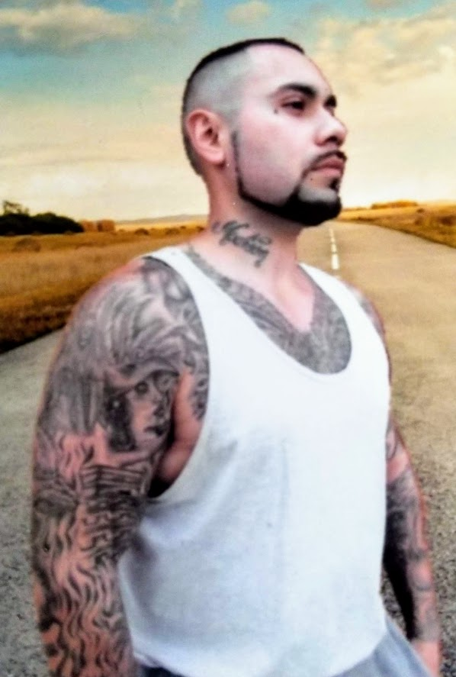

Okay, well I’m obviously not a Calvin Klein model, but what I am is an honest man looking for friends with the ultimate goal of love. I’ve been locked up for eight years now and I’m looking for something real, something of substance. I am an optimistic type of guy who is improving myself physically, mentally, and most importantly spiritually. I am looking for someone who is honest, loyal, funny, and loving. I know you’re out there so quit hiding.
I am studying Law and I have a couple of appeals in the courts right now and I believe I will be out soon. So, if you would like to take this chance at something real with someone real, don’t hesitate to write me. I am open to writing overseas. Looking to snail mail and talk on the phone.
Ruben Delgado

