reachingaprisoner.com
Hi! I’m Brandon. I’m thirty-two years old and have served the past eleven years of my life in prison for robbery. My sentence is thirty years, but I’m eligible for release on parole after fifteen. Since my incarceration, I’ve obtained my GED and two associates degrees from Lee College. My goal is to also obtain my bachelor’s degree from Adam’s State University before my parole date in four years. I’m also the lead unit welder (have been for three years) here at the Ellis Unit. I’m very outgoing and energetic. I love being outside and building things with my hands. I am also a bit of a fitness junky. I love to laugh and make others laugh. I’m not very good at emotionally hostile situations though. I guess you could say I’m a work in progress. What I’m looking for are friends to help keep my mind out there and focused on free world things large sentences often produce an institutionalized way of thinking. I like to think I have a great character and really just wanna still be me when I come home. Well, maybe a bit more mature! I am also a sucker for love. I’d like to one day meet the kind of girl I just can’t live without. I don’t know if a pen pal site is going to help me there, but I’m hopeful. Anyways, I would love to hear from you. If you write Via “JPay” remember to include your mailing address as we can only respond by regular mail.
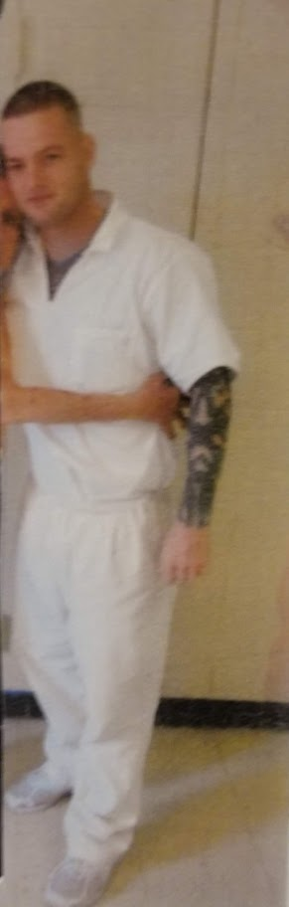
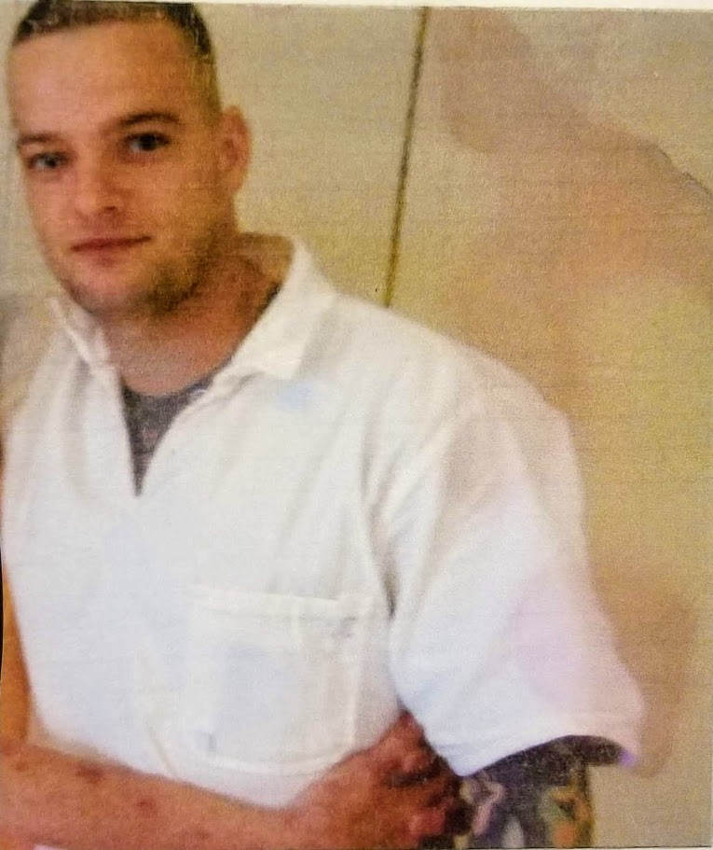

Brandon Blasdell DOC#1639101 T.D.C.J. Ellis Unit 1697 FM 980 Huntsville, TX 77343
DOB: 5/26/1987
Gender: Male
Ethnic Background: Caucasian
Weight: 200lbs.
Height: 5ft 9in
Hair Color: Brown
Eye Color: Blue
Expected Release: Parole date 2/6/2024
Sexual Orientation: Straight
Looking to Write: ANYONE
