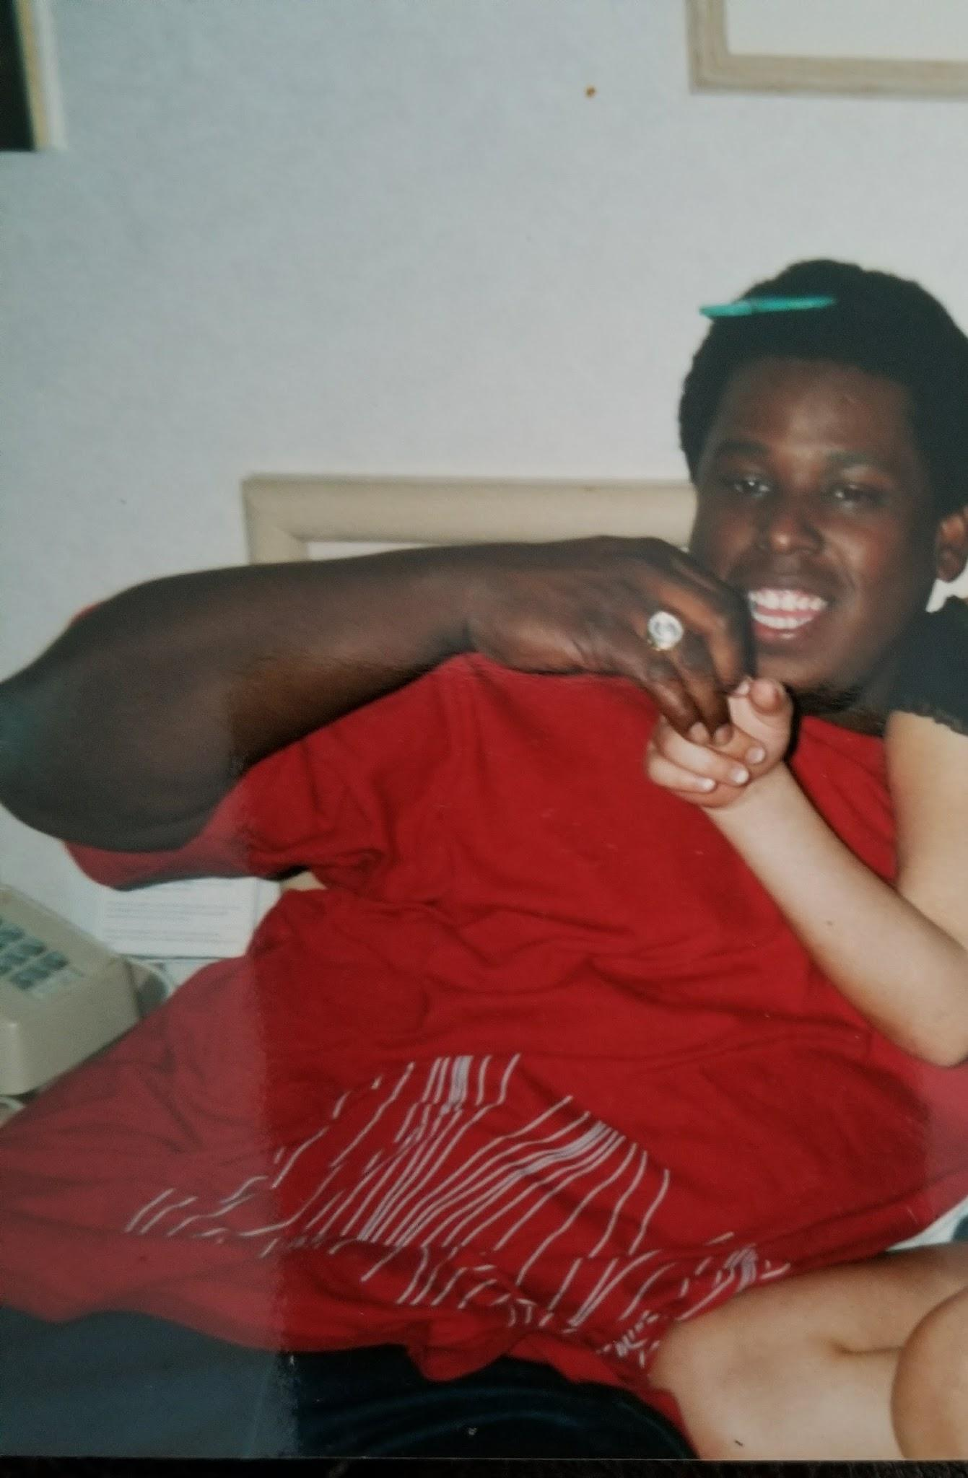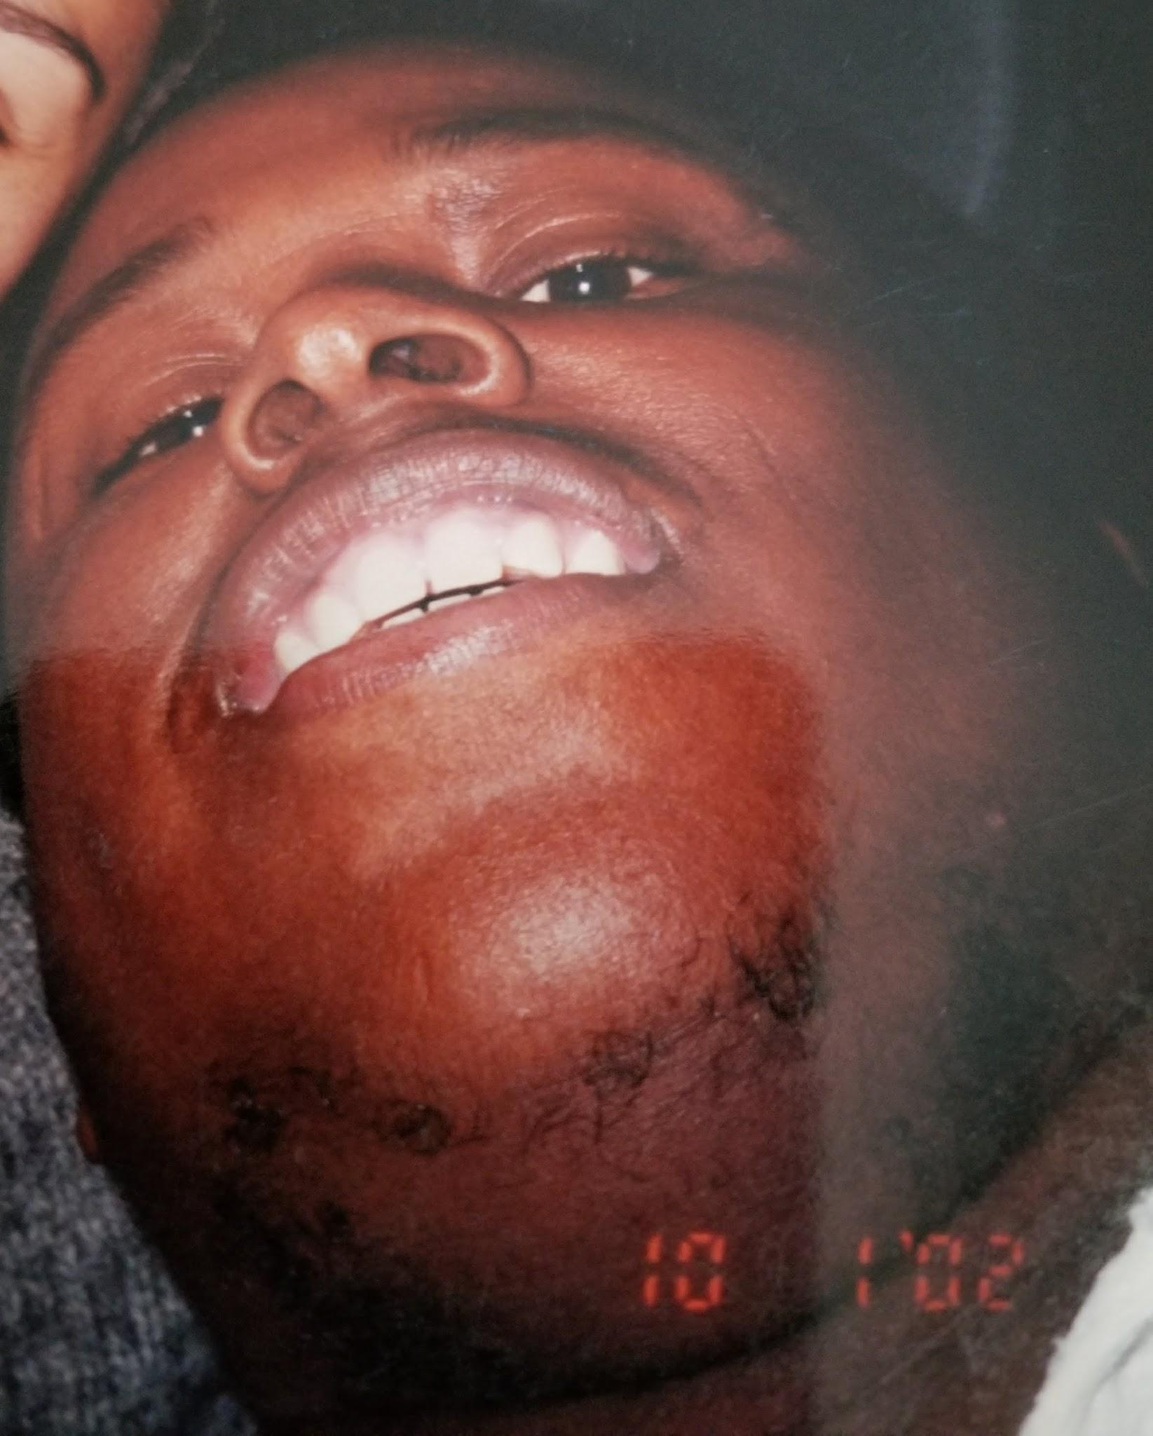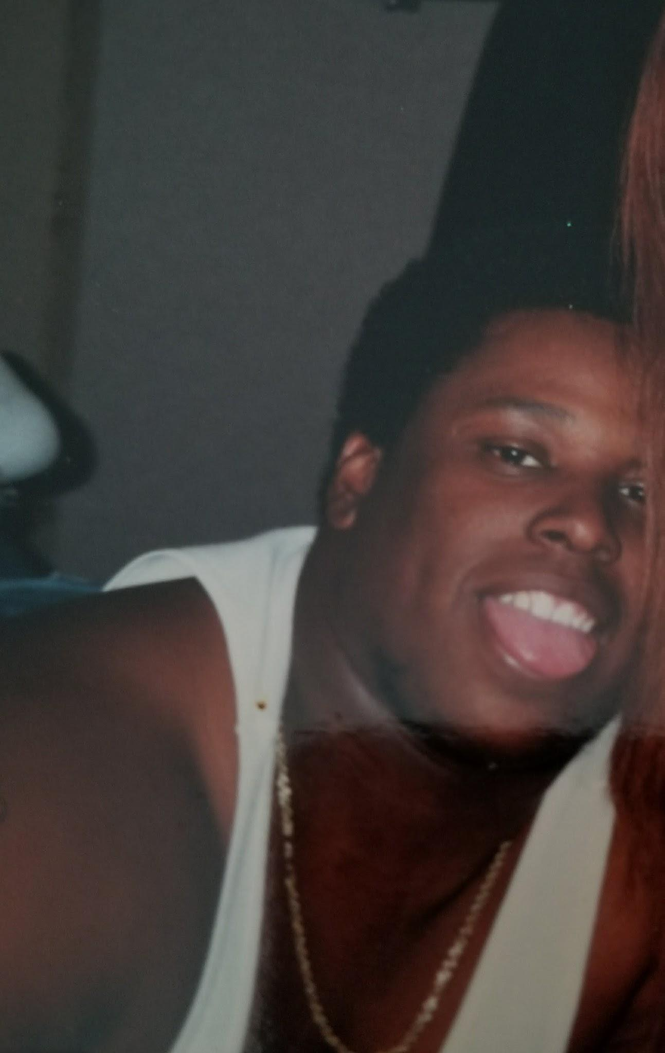
Terrence Fletcher DOC# 1718954
McConnell Unit
3001 S. Emily Dr.
Beeville, TX 78102

In Search Of New Friends;

Hello there Pal, how is life treating you today? Well, my name is Terrence and I am in search of meeting new people and making new friends from all walks of life. Are you tired of meeting new people who seem like their nice in the beginning and time passes by and you realize they aren’t really that way. Well you don’t have to look any further cause if you reach out to me I promise to put 150% into our friendship I promise you to always be trustworthy and honest. Deal?

Let me tell you a little bit about myself. I am a self motivated person who likes to meet new people and make them laugh and smile. I am very outgoing and outspoken. I am also a good listener and advice giver too. Since I have been incarcerated I look for things to improve my life. I am trying to further my education through college courses and vocational trades.

I am looking to for a beautiful individual I can pass the time with and share my experiences in life with. Growing up I was a military child so I have lived all over the United States and Germany! I love to travel and experience different cultures and their ways of living.

My hometown is San Antonio, Texas! I love to watch sports and read novels. Some of my hobbies are riding four wheelers and riding motorcycles are my passion.

Are you a family oriented person? I would like to meet women of all races cause skin color isn’t a barrier for me! Would you like to receive some nice drawings? Are you looking for a friend who will always keep it real with you and can keep your secrets confidential? Then please look no further and contact me! Do you believe you can find a good honest gentleman behind bars? If you write you won’t be disappointed

Big Fletch.

