reachinaprisoner.com
Jesse Cantu DOC#1556639 McConnell Unit 3001 Beeville Drive Beeville, TX 78102
DOB: 01/11/1977
Male
Race: Hispanic
Height: 5ft 10in
Weight: 190
Hair Color: Bald
Eye Color: Brown
Expected Release Date: 07/15/2027
Sexual Orientation: Straight
Wanting to Write: Anyone
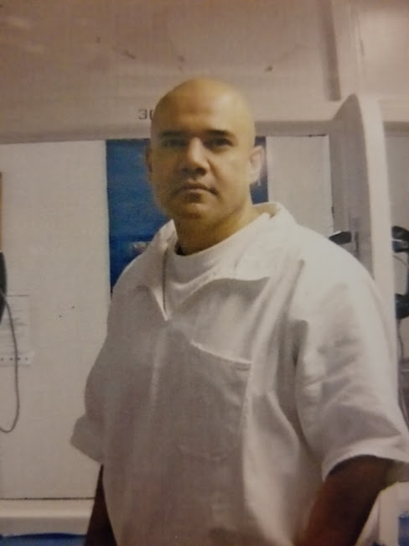
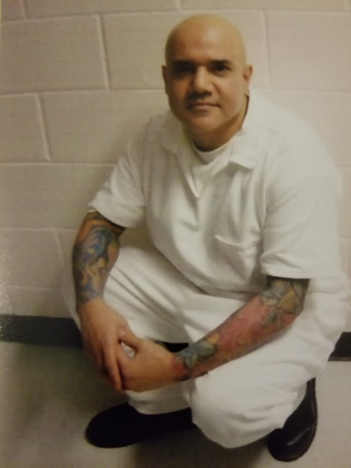

Dear Viewers,
A pen pal to many, is staying connected through paper, ink and postage, a way to pass time. To others, it’s hope and inspiration, barely hanging on with the glue of that postage stamp, making the best of time.
I’m interested in making new friends; I understand firsthand how precious time is, whether it’s 15 minutes to sit and write a letter or 15 years waiting to receive a letter. I also know how it feels to be alone. It’s said that this is one of the loneliest places in the world. A world of its own, made of nothing but razor wire, concrete and steal; though I am not as cold and heartless as this place.
If you are reading my words and you find yourself wanting to talk, vent or in need of someone to listen, lets get to know each other. I promise not to judge you, look down on you, or lie to you. I’m no better than the next man or women. I too am mortal. I’ve made a few mistakes in my in life, the rest of my misfortune is the results of very bad choices. I’ve lost a lot and I have learned a lot, but I’m still undefeated.
I believe every coin has two sides. Those of us who have done bad are capable of great things, and those of us who have done nothing but good, well. That just too bad =) I’m no saint, I’m not here for singing in the choir 0r picking wild flowers.
I’m a bad boy and that’s the truth, but I’m looking for what’s good, what’s right, and some kind of positive. I’ve learned it’s better to fail in doing something than to succeed in doing nothing. I’m shooting for the moon, and if I miss that’s ok…….cause I’ll land with the stars.
Before I close let me thank “you” for the time and consideration and leave you with something to think about……. “It’s impossible” said pride; “It’s risky” said experience; “it’s pointless” said reason. “GIVE IT A TRY”, whispered the heart.
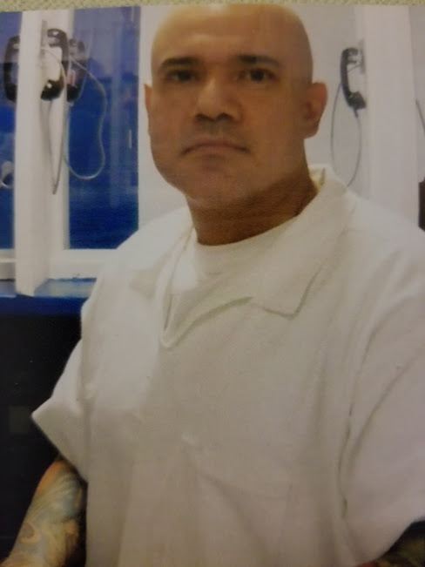

Inspired by you,
Jesse

