Reachingaprisoner.com

Rose Marie Kirk DOC#1199804 Central VA Correctional Facility 6900 Courthouse Rd. Chesterfield, VA 23832
DOB: 05/13/1979
Gender: Female
Ethnic Background: Native American
Height: 5ft. 11in.
Weight: 160lbs.
Hair Color: Brown
Eye Color: Brown
Expected Release: 5/25/2019
Sexual Orientation: Bisexual
Willing to Write: ANYONE
Has access to: JPay
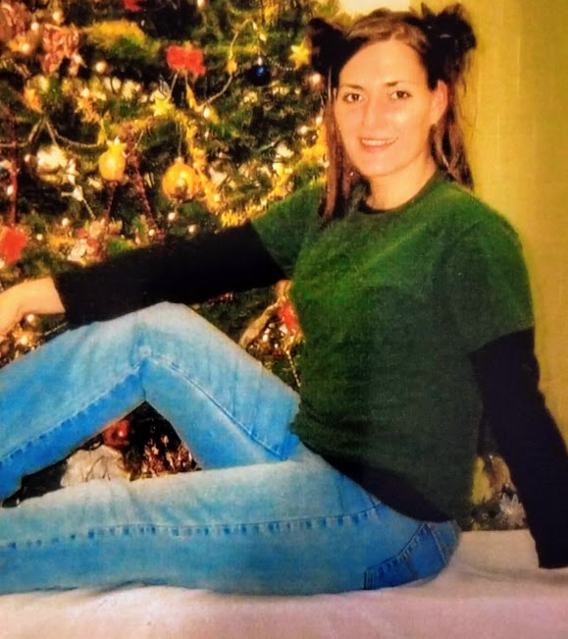

Hello, my name is Rose, I am 39 years old and currently incarcerated in Virginia. My release is in May of 2019. I am from New Jersey; however, I have lived in Virginia for the last 15 years. I plan to stay in Virginia for a while once I’m released but would like to relocate soon. I am looking for a friendship possibly more if I am lucky enough to meet someone special. I would love to find someone special to share my life with. I am a Taurus. I am very loyal, outgoing, fun and open-minded. I love nature and animals. I am very spirited nod grounded. I love music, traveling and new experiences. I take pride in my appearance and I am very health conscious. I enjoy staying healthy and active. I am looking for someone I can bake cookies with at 3am or dance with on the beach at 5am. Someone I can catch a festival with and take a weekend trip with to go see street art. I am determined to turn this experience into something positive. I will never let a bad decision define who I am or determine my future. Please contact me through an email on JPay if I sound like someone you would like to get to know.

