reachingaprisoner.com

Raul Fuentes DOC#2160376 Ellis Unit 1697 FM 980 Huntsville, TX 77343
DOB: 10/2/1987
Gender: Male
Ethnic Background: Hispanic
Height: 5ft 10in
Weight: 180lbs.
Hair Color: Black
Eye Color: Black
Expected Release: 7/29/2020
Sexual Orientation: Straight
Willing to Write: ANYONE
Has access to: JPAY
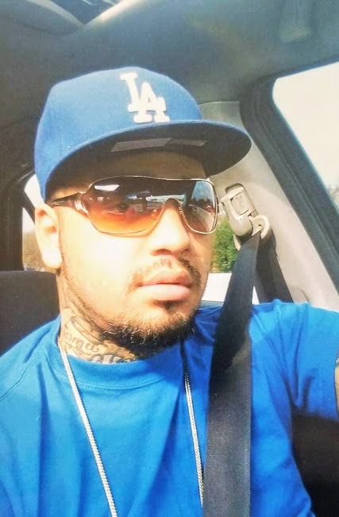

Hey! I’m new to this and I’m hoping to catch someone’s attention while I’m in here. My name is Raul and I’m looking forward to meeting new people and friends. A little about myself that you aren’t able to tell by looking at my photo is……..I stand 5 feet 10 inches tall. I weigh about 180 pounds. I’m a very outgoing person with a great sense of humor and I love seeing people with smiles and having an awesome time with me! I’m an average size man and upon meeting me, I am a very good looking and presentable gentlemen. I am smart and along with that comes confidence plus I am able to hold and keep a great intellectual conversation. I am also a humble down to earth, family-oriented kind of guy. I most definitely know how to treat a woman the way she should be treated. YES, ladies there are still gentlemen left in this world. Let’s, just say I look like a Bad Boy and dress like a prep and have the mind of a nerd. When I am in the free world, I do work along with spending as much time with my three mini Me’s. Not that I don’t make time for myself and dating, because if a person wants someone or something, they make time available. One thing I like most about myself is my smile! Good hygiene is a MUST, along with great grooming habits. I have a nice, wide, defined broad shoulders. I’m not cocky, self-centered or arrogant, and I was raised to have self-confidence. I do not know the difference. I can go on and on about any and everything, lets save that for who’s found me interested and wishes to get to know one another. Don’t be shy, I’m looking forward to hearing from you!!!!!
