Reachingaprisoner.com
First and foremost, peace and blessings to everyone, Happy New Year! My name is Primis Haley and I prefer to be called A.J. it’s the name my late sister called me. A little about me, I am 32 years old, I stand 6ft 4in., 250lbs. I am a fun loving, caring person who feels life is nothing without a little fun every now and then. I real softy when it comes to music, I like R&B, and Country. But I will listen to a little of everything from time to time. My favorite song right now is “Speechless” by Dan and Shay, that’s an amazing piece of art!!! (LOL) Lately I have been into poems really strong they seem to bring out a piece of me that I find peaceful!

Aramis Haley DOC#1657067 Robertson Unit 12071 FM 3522 Abilene, TX 79601-749
DOB: 7/13/1986
Gender: Male
Ethnic Background: African American
Height: 6ft 4in
Weight: 260lbs.
Hair Color: Black
Eye Color: Black
Expected Release: 5/3/2022
Sexual Orientation: Straight
Looking to Write: ANYONE
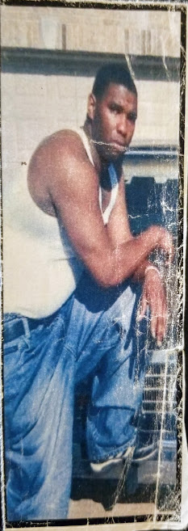

Now while I’m here in this place I am pushing myself to learn as many things as I can. Things that could and would be useful to me and for me for my release. I have quite a few things I would like to try and build which will end with my own business. So right now, I am also a self-help junky!! (LOL) Not looking for anything major just enough to be content in life.
I’m looking for someone who will be their self. Someone who I could inspire and motivate and het the same back from them. Someone to laugh and joke with, have fun. A person who’s looking for a lasting friendship or whatever it is your looking for as long as it’s long term. So, with that I pray something caught your attention and your write to find out more about me. Until then, Peace and Blessings, may this New Year bring you happiness we all look for in life.
P.S. If you use JPay to write please include address for my reply.

