reachingaprisoner.com
About Me:

Cody D. Jensen DOC#88070 St. Anthony Work Camp 125 North 8th W St. Anthony, Idaho, 83445
DOB: 12/22/1978
Gender: Male
Ethnic Background: Sicilian
Height: 6ft
Weight: 185lbs.
Hair Color: Brown
Eye Color: Hazel
Expected Release: June 2021
Looking to Write: ANYONE
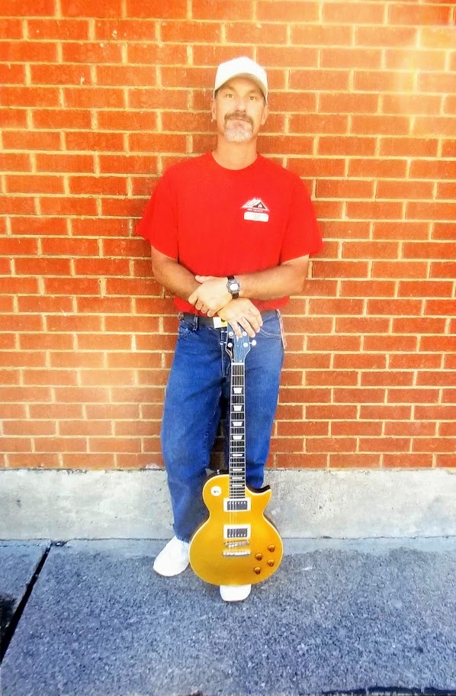

I’m 40 years old, 6ft tall and happily divorced. I like fishing, camping, Taking the ol Harley out, playing my guitar, hanging out with laid back fun people, off roading in my truck, telling good old dirty jokes. I like any music, but rap, I can really play the blues, having BBG’s, love to work.
I’m a wild land firefighter for IDOC, on the streets I’m a welder/fabricator. I like anything and anyone fun, even chasing my dog threw the neighborhood…. sometimes.
I don’t like dishonesty, unloyalty, game playing people who are not real, drama, picking up my dirt bike and limping back to my truck after I crashed. You know, simple stuff like that.
So, if you are in the “don’t like” section. Please avoid this profile cause I’m out to have a blast, life is way to short. Looking for someone fun and exciting, if this is you, put some pen to paper or JPay Cody Jensen #88070.
TTYS

