reachingaprisoner.com
Hello ladies, my name is Daron and I was born and raised in Maryland. I love having a good time, laughing and meeting new people, which is the main reason why I decided to make a profile. I am going into this with an open mind not expecting anything specific because I know a variety of relationships can evolve depending on our chemistry. I have been incarcerated at this facility for over a year now, but I have a court date in a couple of weeks to overturn my conviction. Yes, send me your blessings I need as many as I can get, LOL, more importantly write me to tell me about what’s on your mind, your interests, hobbies, and things you like and dislike etc….

Daron Johnson DOC#465901 North Branch Correctional Institute 14100 McMullen Highway, S.W. Cumberland, Maryland 21502
DOB: 7/23/1990
Gender: Male
Height: 5ft. 11in.
Weight: 200lbs.
Eye Color: Brown
Expected Release: Soon
Looking to Write: Woman
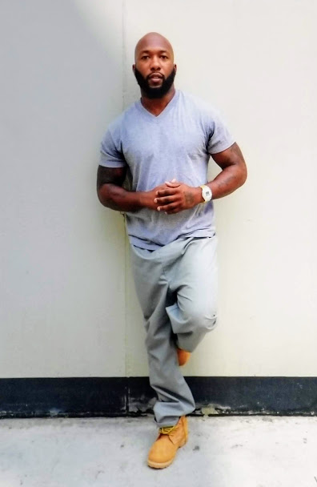

Daron
