reachingaprisoner.com
If I had to describe myself, I would say: I am a Taurus. I am very open, with a great sense of humor. My heart is pure. I stay away from childish games. I’ve been that way the majority of my life. I love education. Never-the-less, I was in the streets, had a name in the streets, and was part of an epidemic where money came easy. That’s what lead to me being framed for a crime I didn’t commit.

Antonio Sherrod DOC#14231-026 Thomson USP E-Unit P.O. Box 1002 Thomson, IL 61285
DOB: 5/10/1980
Gender: Male
Ethnic Background: Black
Height: 5ft. 11in.
Weight: 170lbs.
Hair Color: Bald
Eye Color: Brown
Expected Release: Life for now
Looking to Write: Woman
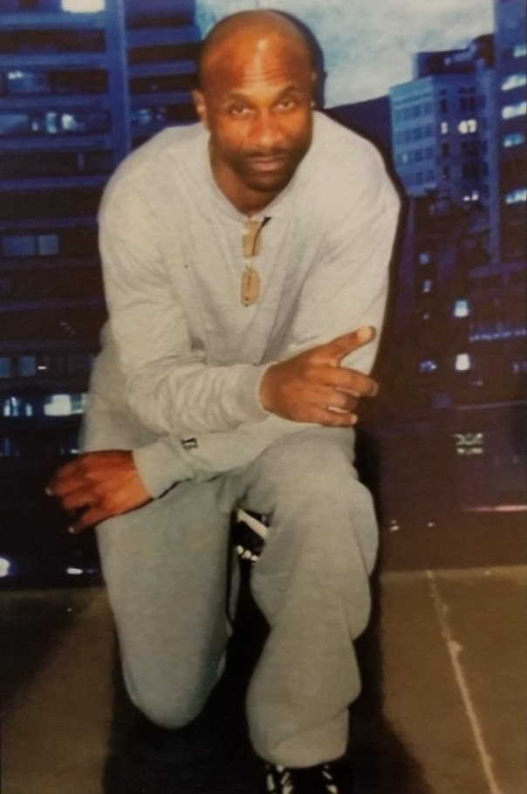

Very soon we’ll prove my innocence….
I love creative writing, sports, and I read a lot, and try to stay in-tune with social media.
I’m hoping to locate someone I can get to know. Someone who will put the time and effort to get to know me. Someone who will like to know me as a person, and not judge me by the character defamation the Government has created.
My days here get lonely at times….
And, it hurts my heart to not get mail from woman……So, if you have time: reach out, I’ll reach back.
Sherrod
