reachingaprisoner.com
I’m currently not in a place where I want to be right now physically, but mentally I’m at my best; continuing to better myself daily. Even though I may be incarcerated I have a lot on the table. I’m out going, loving, determined and enjoy meeting new people. I’m definitely someone you can always depend on. I’m looking for genuine friendship, and maybe more if the opportunity presents itself. Good people are hard to find, and sincere relationships are seldom. If you decide to contact me on JPay my DOC# is 401418. I look forward to hearing from you.
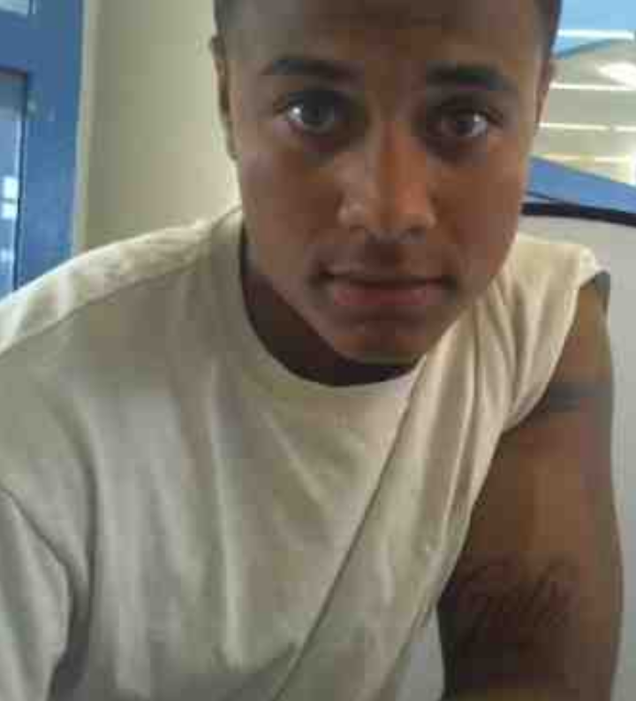

Brandon Pierce, Jr. DOC#401418 Monroe A1-02-01 P.O. Box 888 Monroe, WA 98272
DOB: 8/18/1998
Gender: Male
Height: 5ft 7in
Weight: 190lbs
Sexual Orientation: Straight
Looking to Write: ANYONE

