reachingaprisoner.com
Gilbert Collins DOC#1910685 McConnell Unit 3001 S. Emily Drive Beeville, Tx 78102
Age: 37
Male
Race: ½ Hispanic, ¼ White, ¼ Italian
I speak and write Spanish.
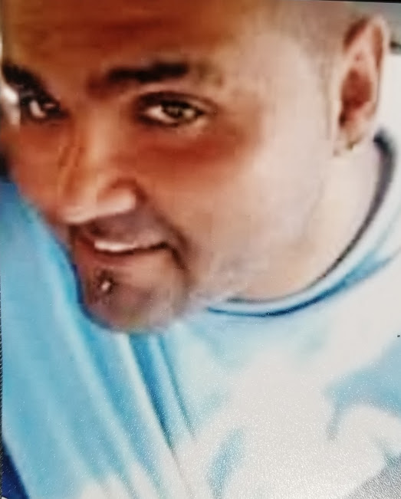
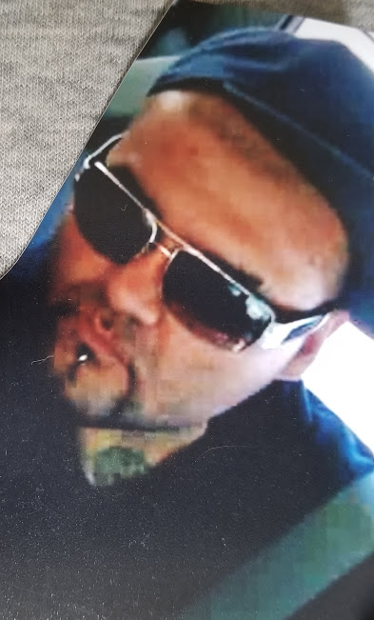

Hello,
My name is Gilbert Junior Collins and I like to say thanks for reading my ad. I’m 37 years old. I’m a really laid back Leo who loves music, Art and good books.
I have many tattoos and I once tattooed for a profession. I like to compose music like rap, and rock. Yet I have an eye for art, being I draw from time to time.
I love my family deeply and when I make friends I tend to make them family as well. I am looking to make and meet friends who are positive, who are willing to listen when times aren’t the best, as I’d like to do when times aren’t the best for you.
I’m ½ Hispanic, ¼ White, and a ¼ Italian and I speak and write Spanish and some Italian. So, if you would like to meet me just drop a few lines and who knows where this will take us. If you’d like to know more please write, I’d love to meet you!
God Bless

