reachingaprisoner.com
Hi may name is Glenn and I’m looking for new people for friendship and correspondence. Been in prison for over 30 years. Have no family or friends on the outside. I receive no mail or visits. Wishing to meet woman of all ages and race from around the world for long term friendship and correspondence. Having someone to correspond with really help pass the time. Enjoy writing, reading, singing and dancing along with the radio, exercising, movies- comedy, sci-fi, western, romance, drama, and suspense. Easy-going, treat others with kindness, open to new ideas and suggestions. Enjoy cooking, house cleaning and yard work. I like working with my hands building, painting, repairing things. Enjoys country, classic rock, jazz, R&B music. Animal lover. Prefers living in the country where I can sit on the porch enjoying nature and watching the wild animals roam and watching the sun rise and set. Country boy with a big heart looking for someone to connect with. Enjoys quiet evenings at hoe watching a good movie or having a conversation with someone special. Enjoys fishing, hiking, camping, and being outdoors. Have 1 adult son. While in prison I’ve gotten my GED, completed a college vocational trade in auto repair, auto mechanics and have taken several academic courses and working towards my A.A.S. degree. I have taken several self-help classes for self-improvement. Enjoys learning from others and can accept constructive criticism. Spontaneous, loves to laugh, being happy and enjoy life. Would love to meet someone like-minded to have a mature, intelligent conversation with, but also have a downright silly and funny conversation as well looking for someone who is non-judgmental, forgiving, willing, to give a man a chance. Someone to share ideas, hopes, dreams with. Prefers to live a quiet, peaceful life. If you are a likeminded, looking for a new friend-her I am! You won’t be disappointed. Would love to hear from you regardless of age or race or what part of the world you’re from. Write me directly I’m waiting to hear from you soon!!!
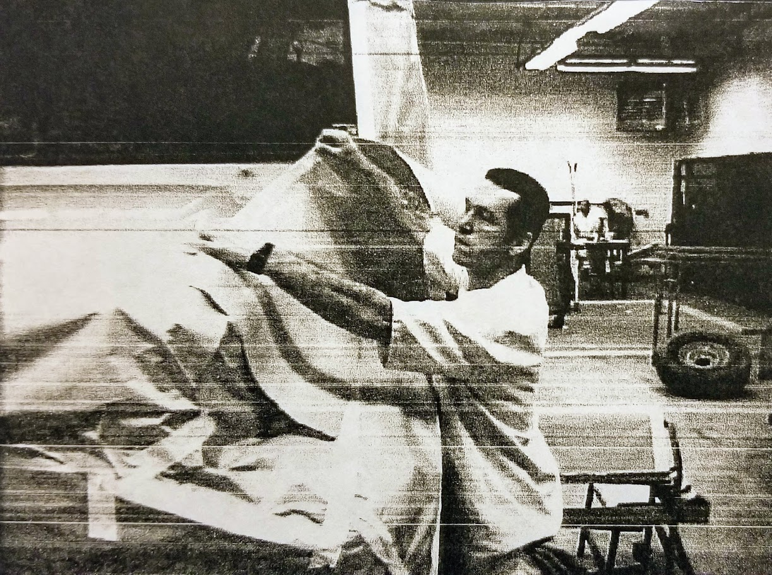

Glenn Ray Macks DOC#395256 Alfred Hughs (4E-1B) Rt. 2 Box 440 Gatesville, TX 76597
DOB: 9/29/1964
Gender: Male
Ethnic Background: Caucasian/ Native American
Height: 6ft
Weight: 200lbs.
Hair Color: Brown
Eye Color: Hazel
Expected Release: 2023-2024 Parole- 2044 Discharge
Sexual Orientation: Straight
Looking to Write: Woman
